Jesu, grant me this, I pray AMNS 136 Melody: Song 13 7 7. 7 7.
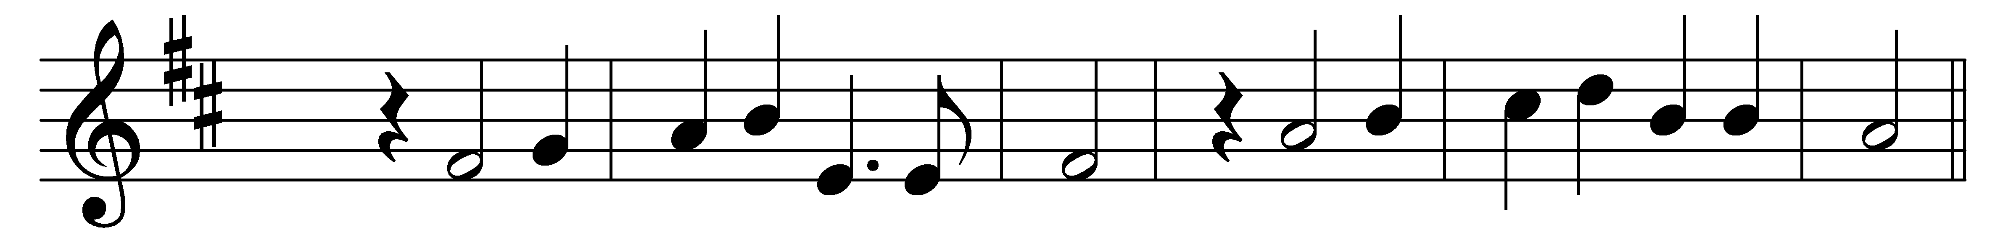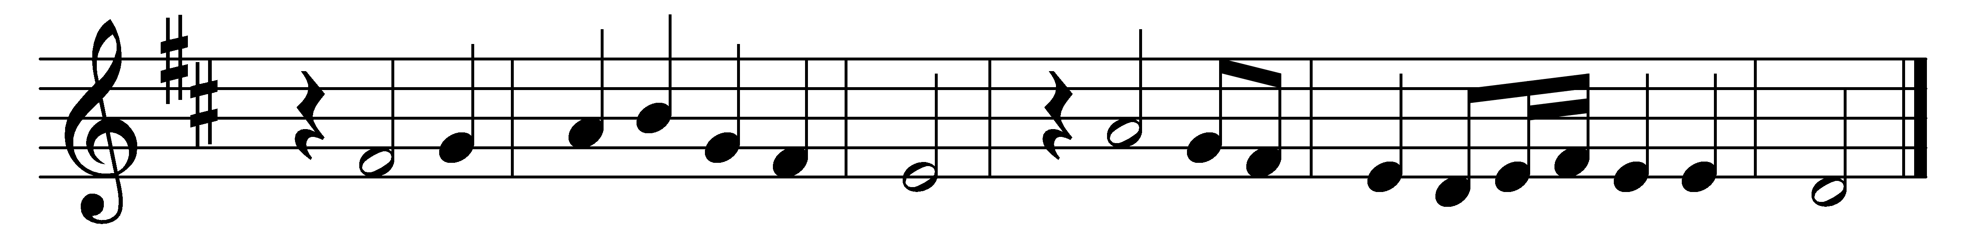

Jesu, grant me this, I pray,
ever in thy heart to stay;
let me evermore abide
hidden in thy wounded side.

If the world or Satan lay
tempting snares about my way,
I am safe when I abide
in thy heart and wounded side.

If the flesh, more dangerous still,
tempt my soul to deeds of ill,
naught I fear when I abide
in thy heart and wounded side.

Death will come one day to me;
Jesu, cast me not from thee:
dying let me still abide
in thy heart and wounded side.

Words: Latin, 17th century, translated by Henry Williams Baker (1821-1877)
Music: Melody and bass by Orlando Gibbons (1583-1625)

