Loving Shepherd of thy sheep AMNS 134 Melody: Buckland 7 7. 7 7.
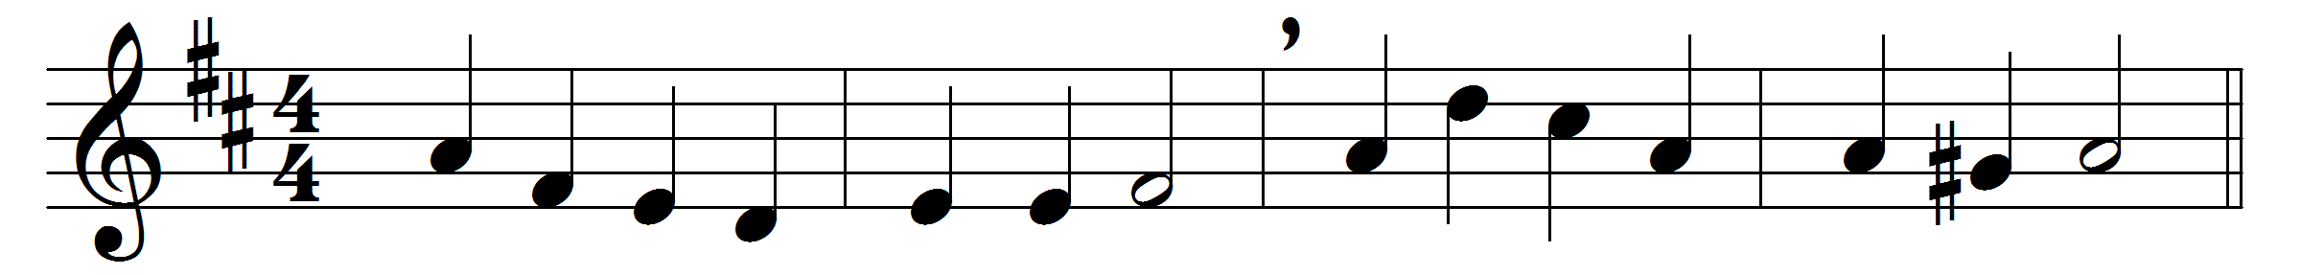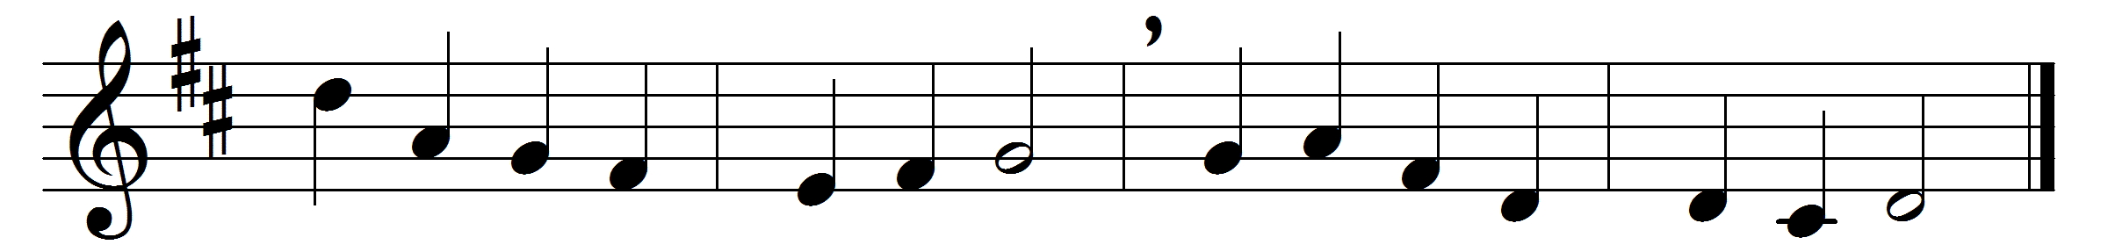

Loving Shepherd of thy sheep,
keep thy lamb, in safety keep;
nothing can thy power withstand,
none can pluck me from thy hand.

Loving Saviour, thou didst give
thine own life that we might live,
and the hands outstretched to bless
bear the cruel nails’ impress.

I would praise thee every day,
gladly all thy will obey,
like thy blessèd ones above
happy in thy precious love.

Loving Shepherd, ever near,
teach thy lamb thy voice to hear;
suffer not my steps to stray
from the straight and narrow way.

Where thou leadest I would go,
walking in thy steps below,
till before my Father’s throne
I shall know as I am known.

Words: Jane Elizabeth Leeson (1809-1881)
Melody: Leighton George Hayne (1836-1883)

