Son of God, eternal Saviour AMNS 132 Melody: Everton 8 7. 8 7. D.
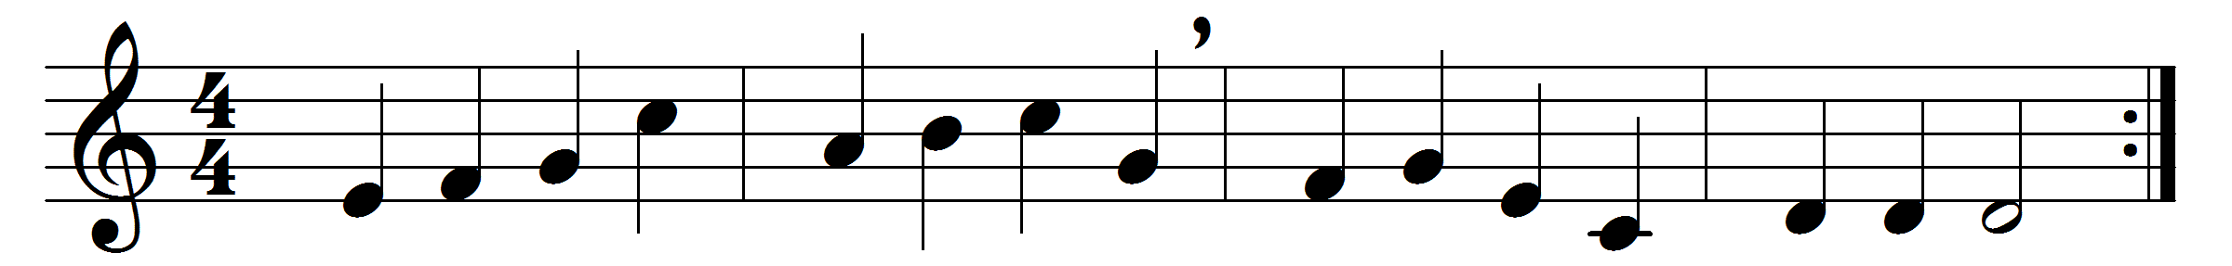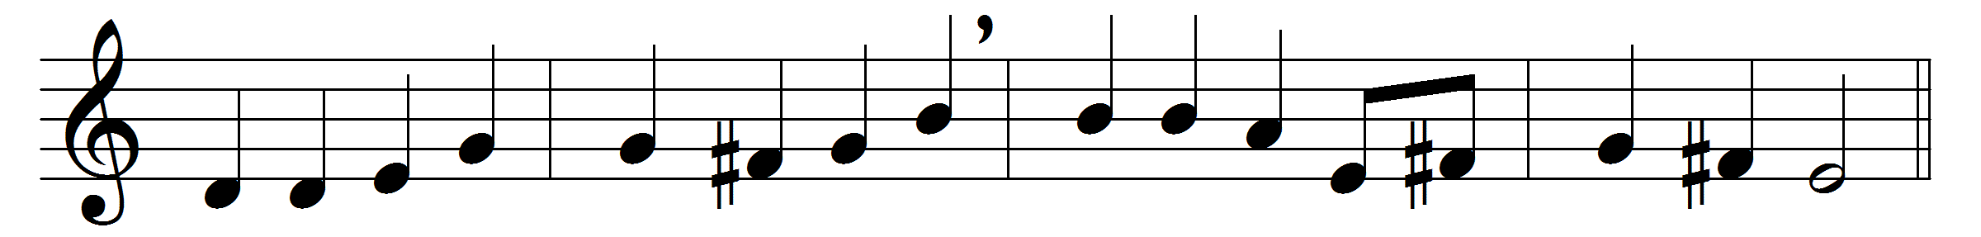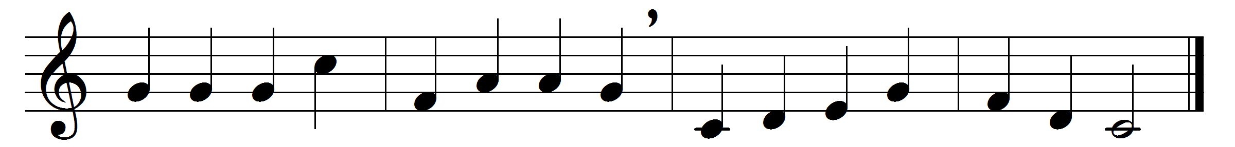

Son of God, eternal Saviour,
source of life and truth and grace,
Son of Man, whose birth incarnate
hallows all our human race,
thou, our Head, who, throned in glory,
for thine own dost ever plead,
fill us with thy love and pity;
heal our wrongs, and help our need.

As thou, Lord, hast lived for others,
so may we for others live;
freely have thy gifts been granted,
freely may thy servants give:
thine the gold and thine the silver,
thine the wealth of land and sea,
we but stewards of thy bounty,
held in solemn trust for thee.

Come, O Christ, and reign among us,
King of love, and Prince of peace;
hush the storm of strife and passion,
bid its cruel discords cease;
by thy patient years of toiling,
by thy silent hours of pain,
quench our fevered thirst of pleasure,
shame our selfish greed of gain.

Son of God, eternal Saviour,
source of life and truth and grace,
Son of Man, whose birth incarnate
hallows all our human race,
thou who prayedst, thou who willest,
that thy people should be one,
grant, O grant our hope’s fruition:
here on earth thy will be done.

Words: Somerset Corry Lowry (1855-1932)
Music: Henry Smart (1813-1879)

