God, that madest earth and heaven AMNS 12 Melody: Ar hyd y nos 8 4. 8 4. 8 8. 8 4.
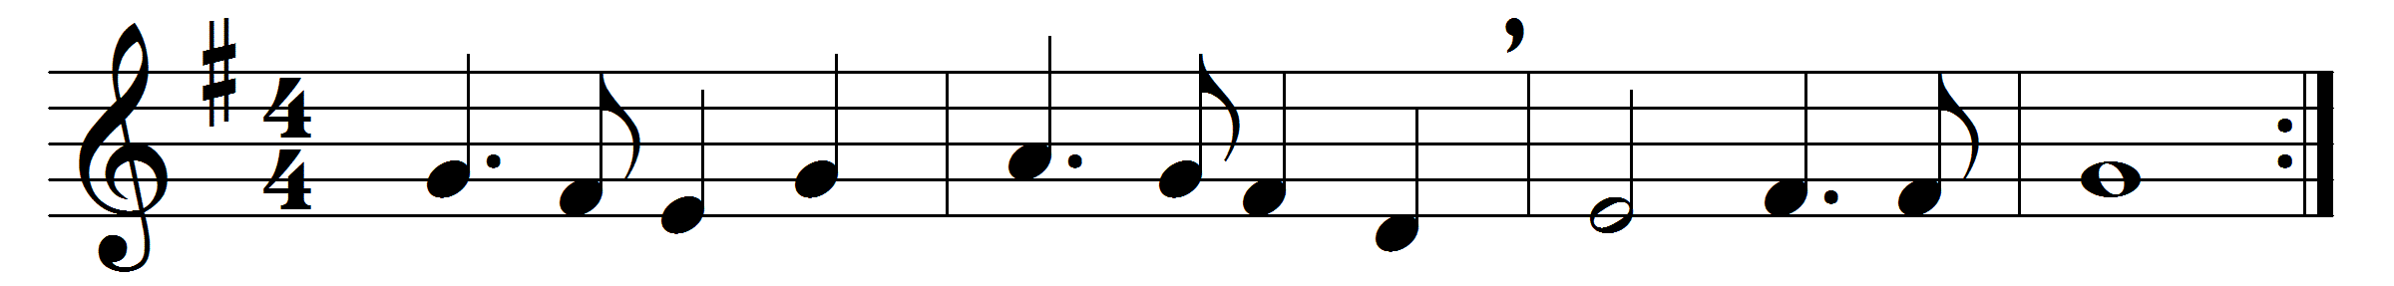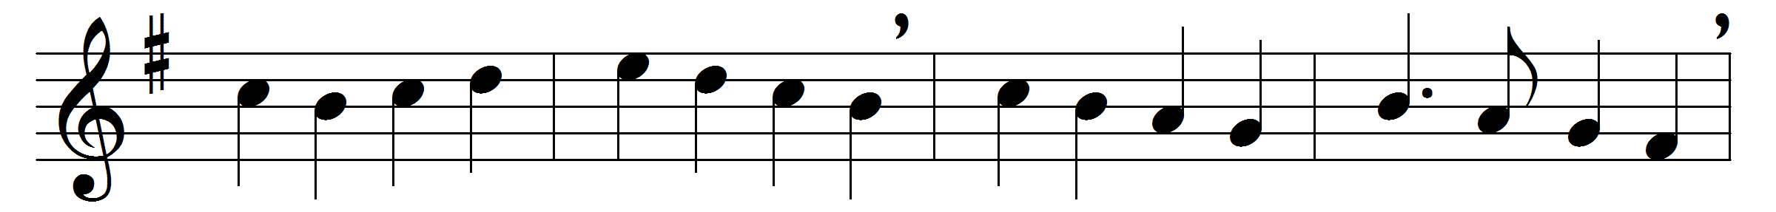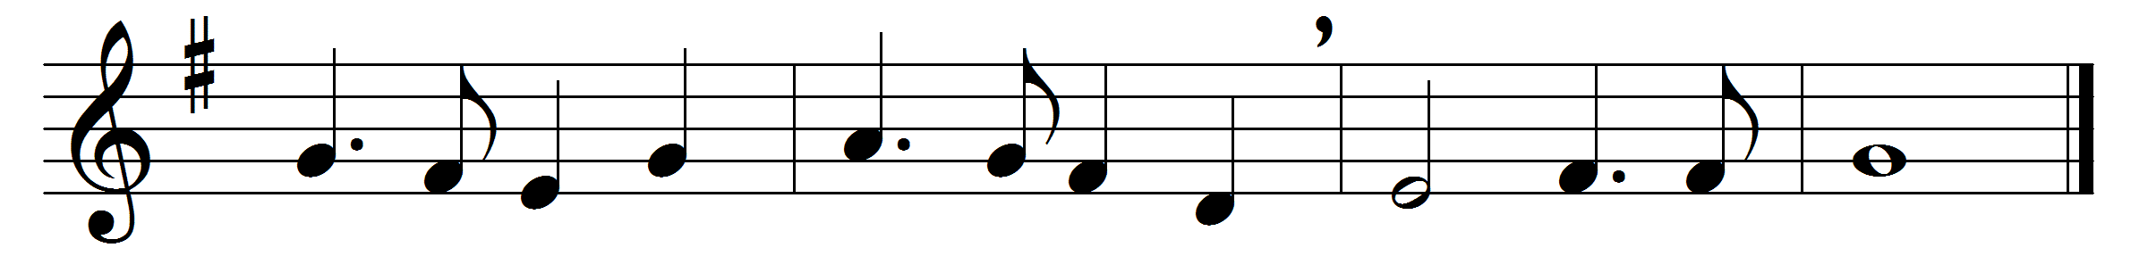

God, that madest earth and heaven,
darkness and light;
who the day for toil hast given,
for rest the night;
may thine angel-guards defend us,
slumber sweet thy mercy send us,
holy dreams and hopes attend us,
this livelong night.
Guard us waking, guard us sleeping,
and, when we die,
may we in thy mighty keeping
all peaceful lie:
when the last dread call shall wake us,
do not thou our God forsake us,
but to reign in glory take us
with thee on high.

Words: Reginald Heber (v. 1) (1783-1826); Richard Whately (v. 2) (1787-1863)
Music: Welsh traditional melody

