Thou art the Way: by thee alone AMNS 128 Melody: St. James C.M.
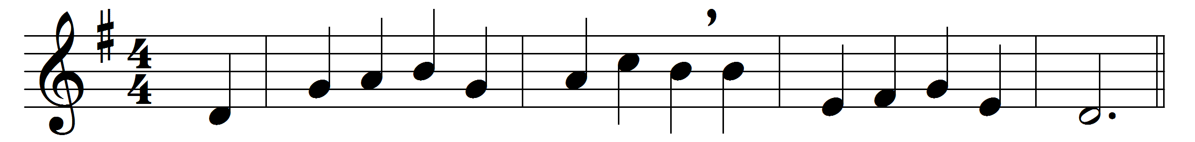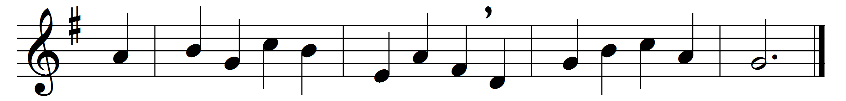

Thou art the Way: by thee alone
from sin and death we flee;
and he who would the Father seek
must seek him, Lord, by thee.
Thou art the Truth: thy word alone
true wisdom can impart;
thou only canst inform the mind
and purify the heart.
Thou art the Life: the rending tomb
proclaims thy conquering arm;
and those who put their trust in thee
nor death nor hell shall harm.
Thou art the Way, the Truth, the Life:
grant us that Way to know,
that Truth to keep, that Life to win,
whose joys eternal flow.

Words: George Washington Doane (1799-1859)
Music: Raphael Courteville (d. 1772)

