O for a thousand tongues to sing AMNS 125 Melody: Richmond C.M.
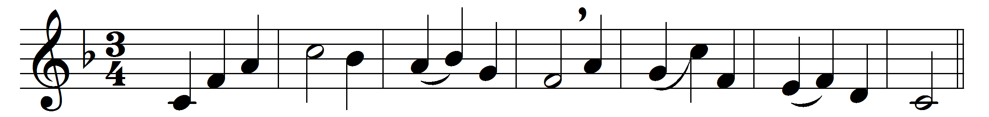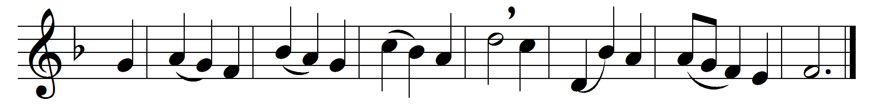

O for a thousand tongues to sing
my dear Redeemer’s praise,
the glories of my God and King,
the triumphs of his grace!

Jesus! the name that charms our fears,
that bids our sorrows cease;
’tis music in the sinner’s ears,
’tis life and health and peace.
He speaks; and, listening to his voice,
new life the dead receive,
the mournful broken hearts rejoice,
the humble poor believe.
Hear him, ye deaf; his praise, ye dumb,
your loosened tongues employ;
ye blind, behold your Saviour come;
and leap, ye lame, for joy!
My gracious Master and my God,
assist me to proclaim
and spread through all the earth abroad
the honours of thy name.

Words: Charles Wesley (1707-1788)
Music: Melody adapted from Thomas Haweis (1734-1820)

