Jesu, the very thought of thee AMNS 120 Melody: Metzler’s Redhead C.M.
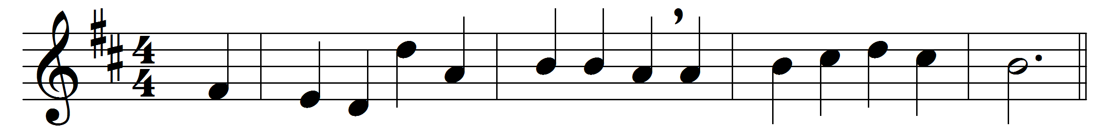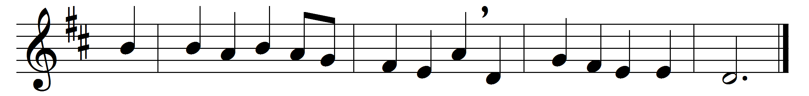

Part One

Jesu, the very thought of thee
with sweetness fills the breast;
but sweeter far thy face to see,
and in thy presence rest.
No voice can sing, no heart can frame,
nor can the memory find,
a sweeter sound than Jesu’s name,
the Saviour of mankind.
O hope of every contrite heart,
O joy of all the meek,
to those who ask how kind thou art,
how good to those who seek!
But what to those who find? Ah, this
nor tongue nor pen can show;
the love of Jesus, what it is
none but his loved ones know.
Jesu, our only joy be thou,
as thou our prize wilt be;
in thee be all our glory now,
and through eternity.
Part Two
O Jesu, King most wonderful,
thou Conqueror renowned,
thou sweetness most ineffable,
in whom all joys are found!
When once thou visitest the heart,
then truth begins to shine,
then earthly vanities depart,
then kindles love divine.
Thee, Jesu, may our voices bless,
thee may we love alone,
and ever in our lives express
the image of thine own.
Abide with us, and let thy light
shine, Lord, on every heart;
dispel the darkness of our night,
and joy to all impart.
Jesu, our love and joy, to thee,
the Virgin’s holy Son,
all might and praise and glory be
while endless ages run.

Words: Latin, c. 12th century, translated by Edward Caswall (1814-1878)
Music: Richard Redhead (1820-1901)

