Sun of my soul AMNS 11 Melody: Hursley L.M.
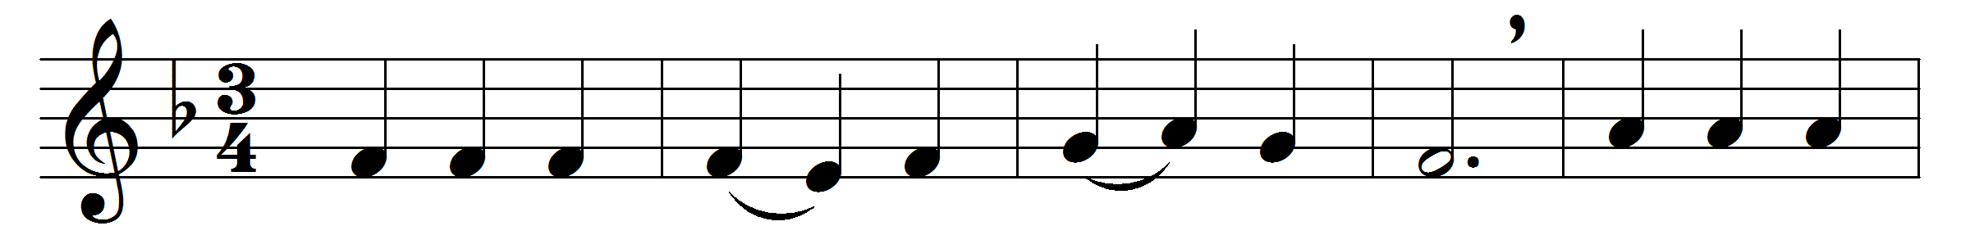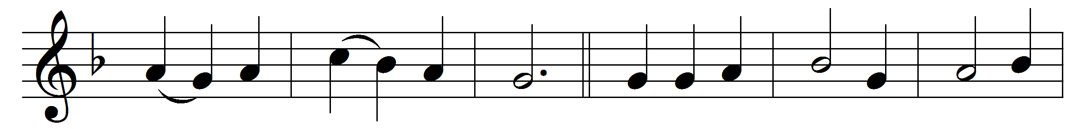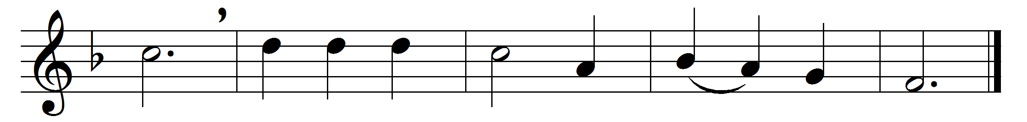

Sun of my soul, thou Saviour dear,
it is not night if thou be near:
O may no earth-born cloud arise
to hide thee from thy servant’s eyes.
When the soft dews of kindly sleep
my wearied eyelids gently steep,
be my last thought, how sweet to rest
for ever on my Saviour’s breast.
Abide with me from morn till eve,
for without thee I cannot live;
abide with me when night is nigh,
for without thee I dare not die.
If some poor wandering child of thine
have spurned to-day the voice divine,
now, Lord, the gracious work begin;
let him no more lie down in sin.
Watch by the sick; enrich the poor
with blessings from thy boundless store;
be every mourner’s sleep to-night
like infant’s slumbers, pure and light.
Come near and bless us when we wake,
ere through the world our way we take;
till in the ocean of thy love
we lose ourselves in heaven above.

Words: John Keble (1792-1866)
Music: Katholisches Gesangbuch, c. 1775

