O love, how deep, how broad, how high! AMNS 119 Melody: Eisenach L.M.
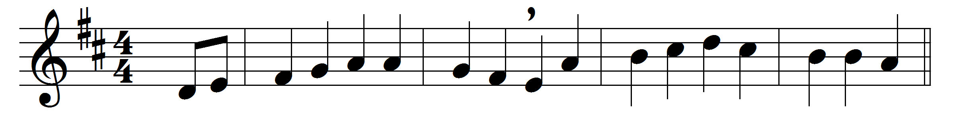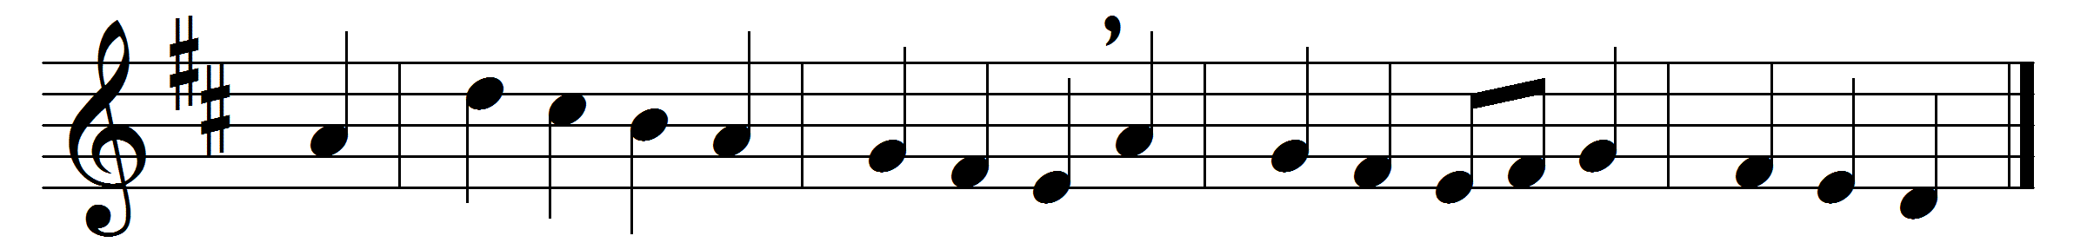

O love, how deep, how broad, how high!
It fills the heart with ecstasy,
that God, the Son of God, should take
our mortal form for mortals’ sake.
He sent no angel to our race
of higher or of lower place,
but wore the robe of human frame
himself, and to this lost world came.
For us he was baptized, and bore
his holy fast, and hungered sore;
for us temptations sharp he knew;
for us the tempter overthrew.
For us to wicked men betrayed,
scourged, mocked, in purple robe arrayed,
he bore the shameful cross and death;
for us at length gave up his breath.
For us he rose from death again,
for us he went on high to reign,
for us he sent his Spirit here
to guide, to strengthen, and to cheer.

To him whose boundless love has won
salvation for us through his Son,
to God the Father, glory be
both now and through eternity.

Words: Ascribed to Thomas à Kempis (c. 1379-1471), translated by Benjamin Webb (1819-1885)
Music: Melody by Johann Hermann Schein (1586-1628), harmony adapted from Johann Sebastian Bach (1685-1750)

