The God of love my shepherd is AMNS 110 Melody: University C.M.
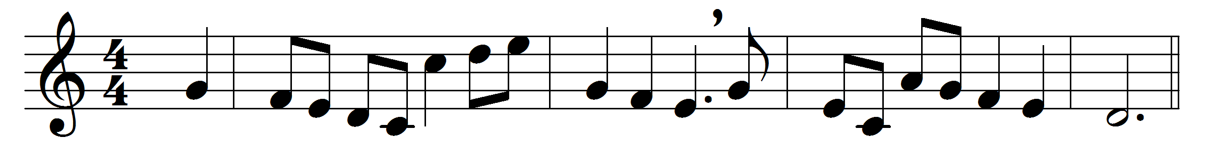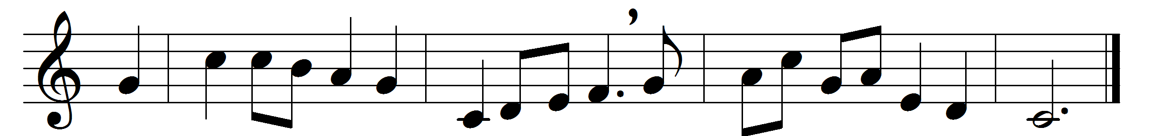

The God of love my shepherd is,
and he that doth me feed;
while he is mine and I am his,
what can I want or need?
He leads me to the tender grass,
where I both feed and rest;
then to the streams that gently pass:
in both I have the best.
Or if I stray, he doth convert,
and bring my mind in frame,
and all this not for my desert,
but for his holy name.
Yea, in death’s shady black abode
well may I walk, not fear;
for thou art with me, and thy rod
to guide, thy staff to bear.
Surely thy sweet and wondrous love
shall measure all my days;
and, as it never shall remove,
so neither shall my praise.

Words: George Herbert (1593-1632)
Music: Charles Collignon (1725-1785)

