When all thy mercies, O my God AMNS 109 Melody: Contemplation C.M.
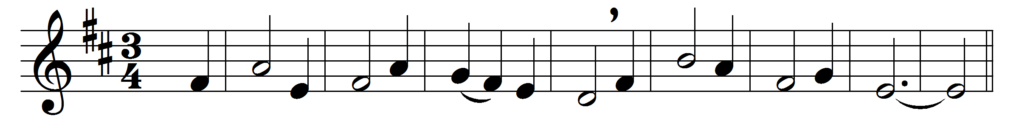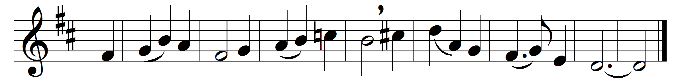

When all thy mercies, O my God,
my rising soul surveys,
transported with the view, I’m lost
in wonder, love, and praise.
Unnumbered comforts to my soul
thy tender care bestowed,
before my infant heart conceived
from whom those comforts flowed.
When in the slippery paths of youth
with heedless steps I ran,
thine arm unseen conveyed me safe,
and led me up to man.
Ten thousand thousand precious gifts
my daily thanks employ,
and not the least a cheerful heart
which tastes those gifts with joy.
Through every period of my life
thy goodness I’ll pursue,
and after death in distant worlds
the glorious theme renew.
Through all eternity to thee
a joyful song I’ll raise;
for O, eternity’s too short
to utter all thy praise.

Words: Joseph Addison (1672-1719)
Music: Frederick Arthur Gore Ouseley (1825-1889)

