The Lord is King! lift up thy voice AMNS 107 Melody: Ivyhatch L.M.
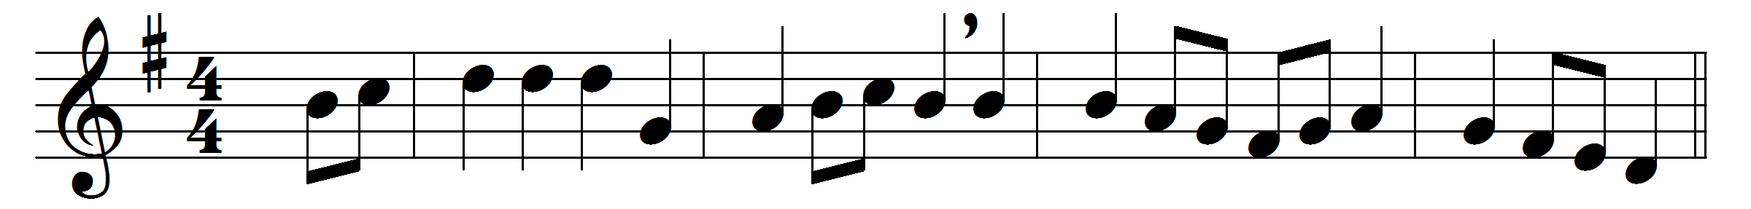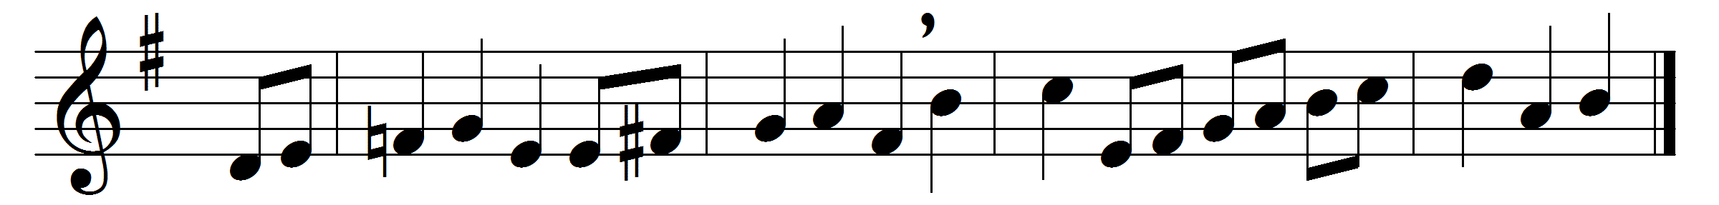

The Lord is King! lift up thy voice,
O earth, and all ye heavens, rejoice;
from world to world the joy shall ring,
‘The Lord omnipotent is King’.
The Lord is King! who then shall dare
resist his will, distrust his care,
or murmur at his wise decrees,
or doubt his royal promises?
He reigns! ye saints, exalt your strains;
your God is King, your Father reigns;
and he is at the Father’s side,
the Man of Love, the Crucified.
Alike pervaded by his eye
all parts of his dominion lie:
this world of ours and worlds unseen,
and thin the boundary between.
One Lord one empire all secures;
he reigns, and life and death are yours;
through earth and heaven one song shall ring,
‘The Lord omnipotent is King’.

Words: Josiah Conder (1789-1855)
Music: Bertram Luard Selby (1853-1918)

