Lord of beauty AMNS 106 Melody: St. Audrey 8 7. 8 7. 8 7.
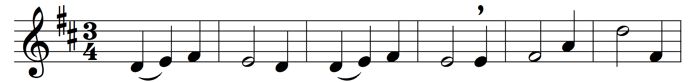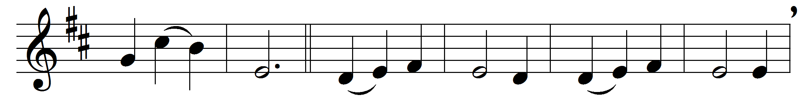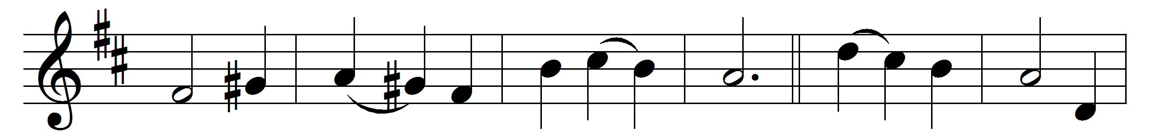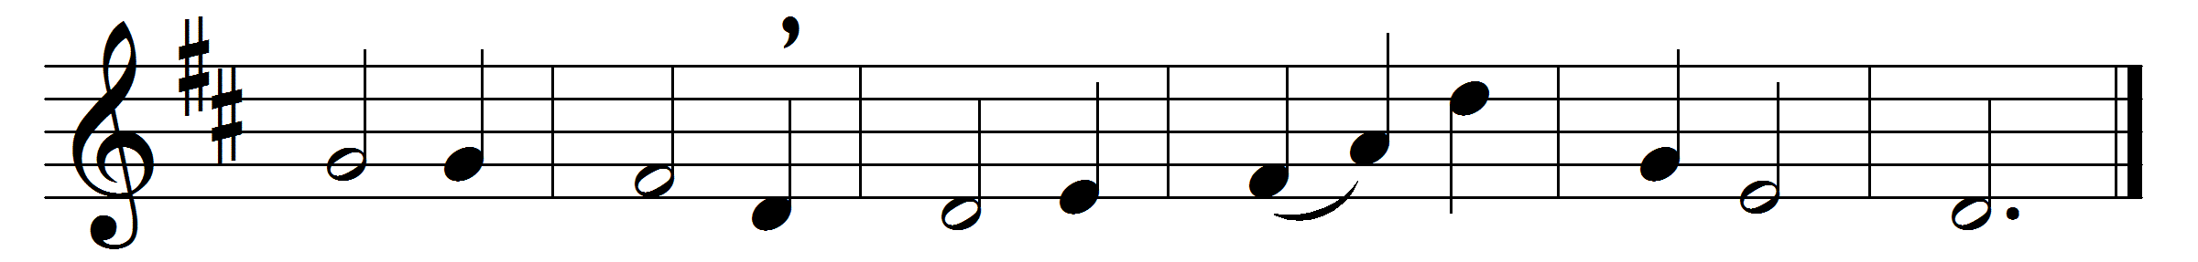

Music: Basil Harwood (1859-1949)

The words to this hymn are still in copyright.

