My God, how wonderful thou art AMNS 102 Melody: Westminster C.M.
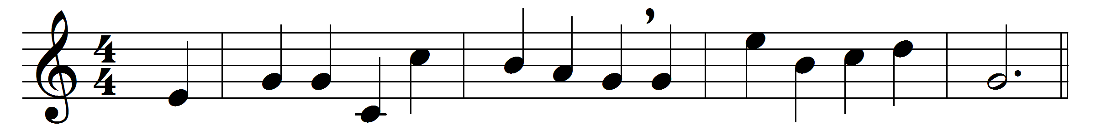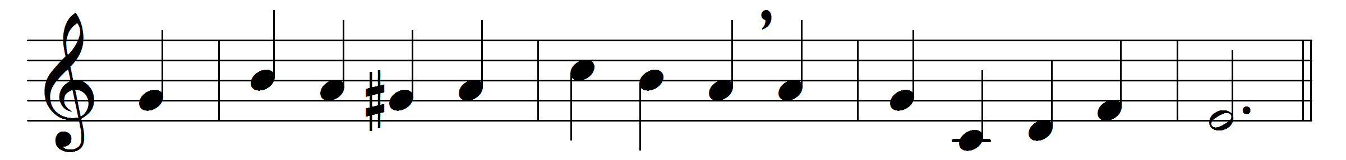

My God, how wonderful thou art,
thy majesty how bright,
how beautiful thy mercy-seat,
in depths of burning light!
How dread are thine eternal years,
O everlasting Lord,
by prostrate spirits day and night
incessantly adored!
How wonderful, how beautiful,
the sight of thee must be,
thine endless wisdom, boundless power,
and aweful purity!

O how I fear thee, living God,
with deepest, tenderest fears,
and worship thee with trembling hope,
and penitential tears!
Yet I may love thee too, O Lord,
almighty as thou art,
for thou hast stooped to ask of me
the love of my poor heart.
No earthly father loves like thee,
no mother, e’er so mild,
bears and forbears as thou hast done
with me thy sinful child.
Father of Jesus, love’s reward,
what rapture will it be,
prostrate before thy throne to lie,
and gaze and gaze on thee!

Words: Frederick William Faber (1814-1863)
Music: James Turle (1802-1882)

