Dost thou in a manger lie Hymnal 1982 no. 97 Melody: Dies est laetitiae 7 6. 7 6. 7 7 5. 7 7 5.
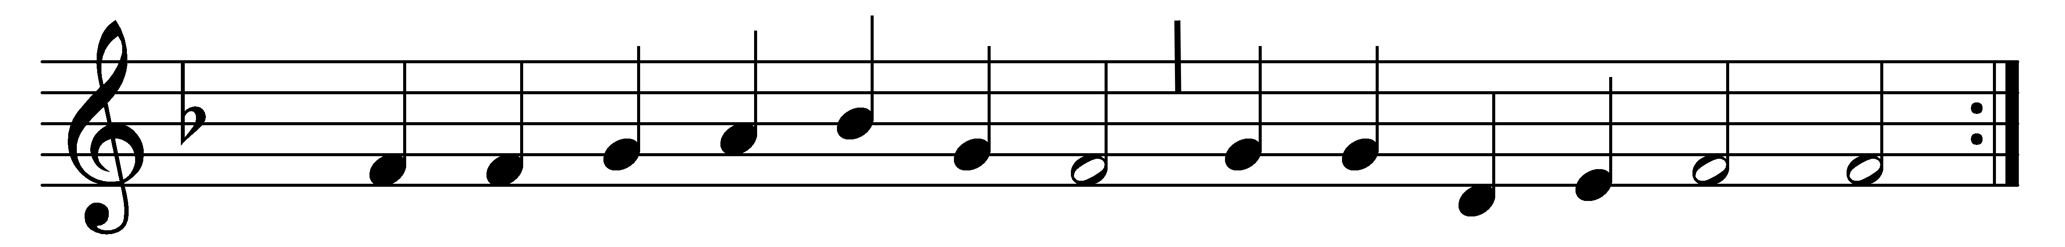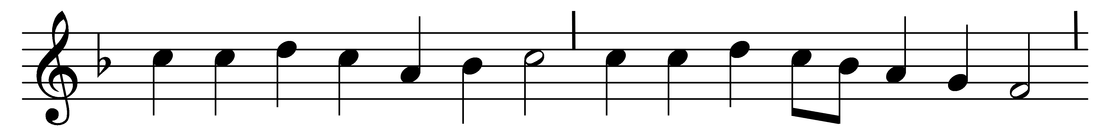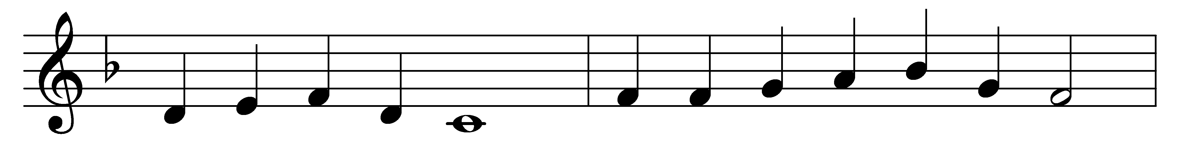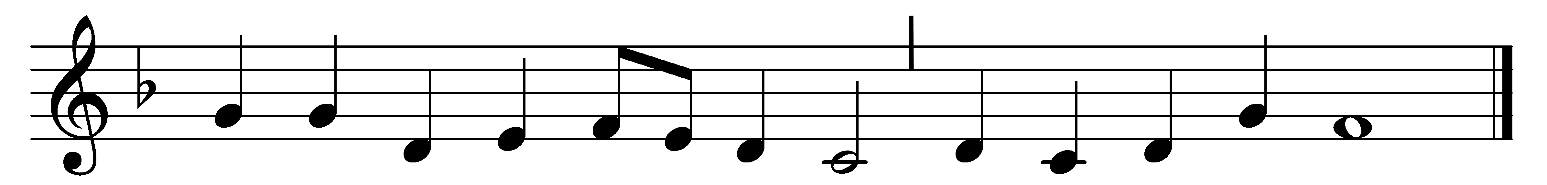

Dost thou in a manger lie,
who hast all created,
stretching infant hands on high,
Savior, long awaited?
If a monarch, where thy state?
Where thy court on thee to wait?
Scepter, crown, and sphere?
Here no regal pomp we see,
nought but need and penury:
why thus cradled here?

“For the world a love supreme
brought me to this stable;
all creation to redeem
I alone am able.
By this lowly birth of mine,
sinner, riches shall be thine,
matchless gifts and free;
willingly this yoke I take,
and this sacrifice I make,
heaping joys for thee.”

Christ we praise with voices bold,
laud and honor raising;
for these mercies manifold
join the hosts in praising:
Father, glory be to thee
for the wondrous charity
of thy Son, our Lord.
Better witness to thy worth,
purer praise than ours on earth,
angels’ songs afford.

Words: Jean Mauburn (1460-1503), translated by Elizabeth Rundle Charles (1828-1896) and others
Music: Melody from Piae Cantiones, 1582

