On this day earth shall ring Hymnal 1982 no. 92
Melody: Personent hodie 6 6 6. 6 6. with refrain
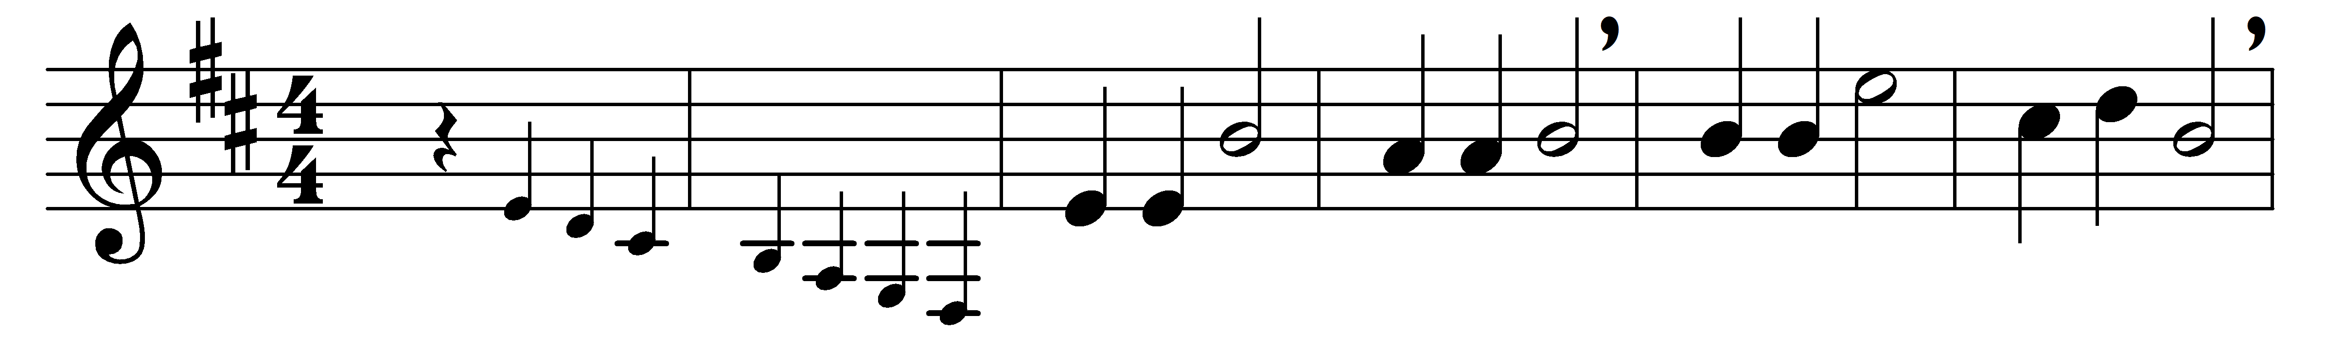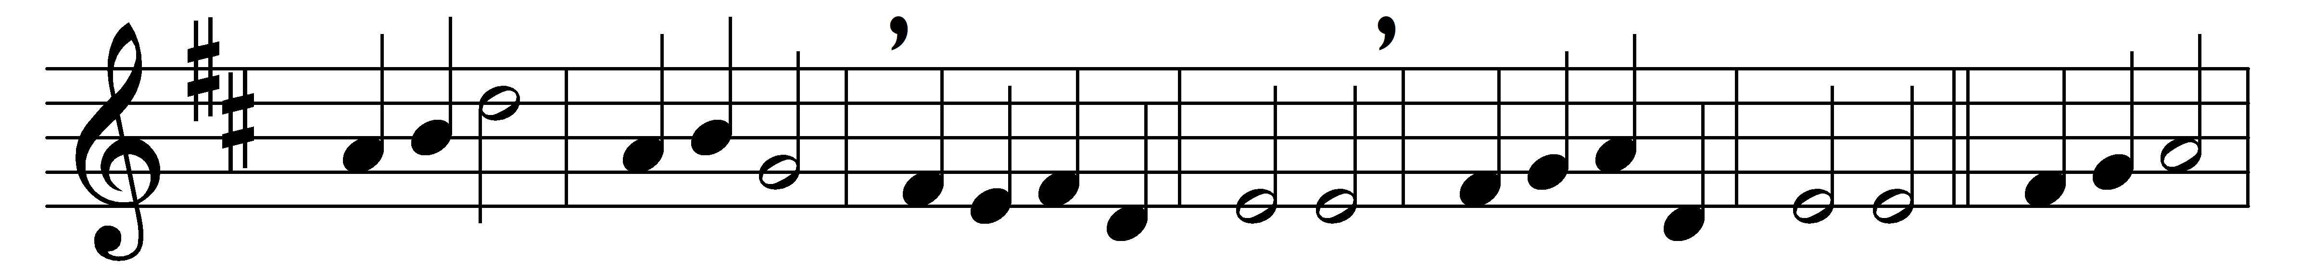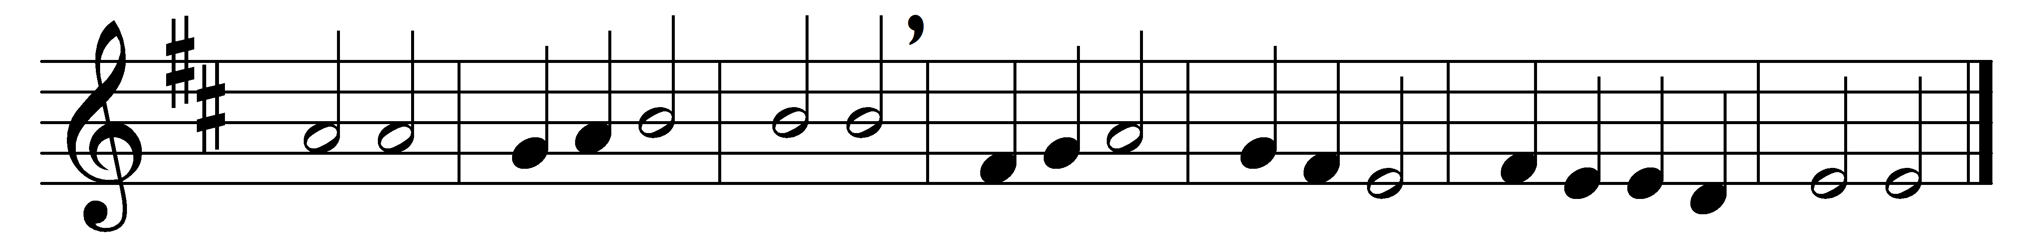

On this day earth shall ring
with the song children sing
to the Lord, Christ our King,
born on earth to save us;
him the Father gave us.
(Refrain:) Id-e-o-o-o, id-e-o-o-o,
Ideo gloria in excelsis Deo!

His the doom, ours the mirth;
when he came down to earth
Bethlehem saw his birth;
ox and ass beside him
from the cold would hide him.
(Refrain)

God’s bright star, o’er his head,
Wise Men three to him led;
kneel they low by his bed,
lay their gifts before him,
praise him and adore him.
(Refrain)

On this day angels sing;
with their song earth shall ring,
praising Christ, heaven’s King,
born on earth to save us;
peace and love he gave us.
(Refrain)

Words: From Piae Cantiones, 1582, translated by Jane Marian Joseph (1894-1929)
Music: Melody from Piae Cantiones, 1582, harmonised by Gustav Holst (1874-1934)

