It came upon the midnight clear Hymnal 1982 no. 89 Melody: Carol D.C.M.
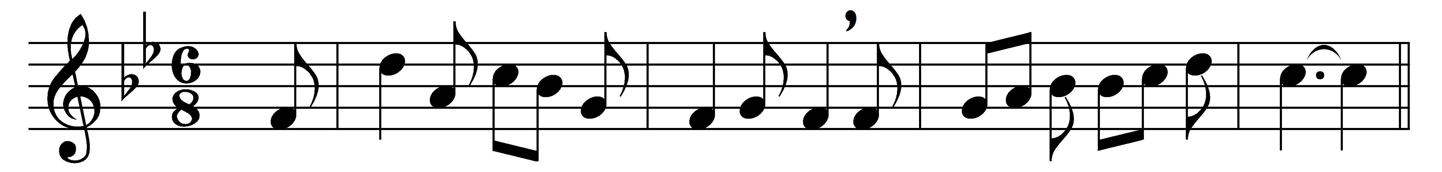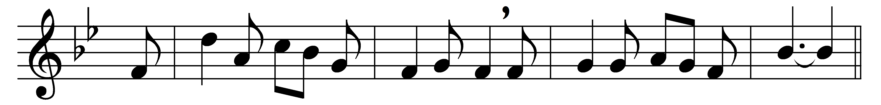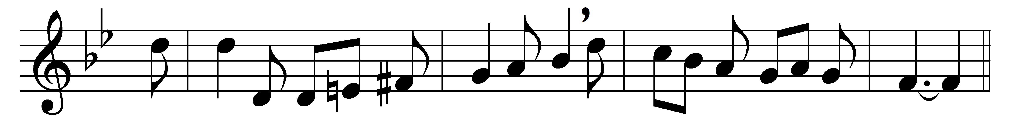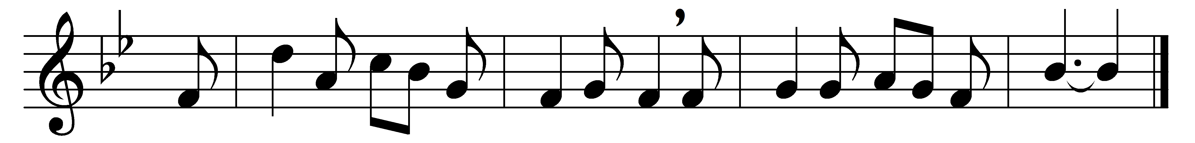

It came upon the midnight clear,
that glorious song of old,
from angels bending near the earth
to touch their harps of gold:
‘Peace on the earth, good will to men,
from heaven’s all-gracious King.’
The world in solemn stillness lay
to hear the angels sing.

Still through the cloven skies they come
with peaceful wings unfurled,
and still their heavenly music floats
o’er all the weary world;
above its sad and lowly plains
they bend on hovering wing,
and ever o’er its Babel-sounds
the blessèd angels sing.

Yet with the woes of sin and strife
the world has suffered long;
beneath the heavenly hymn have rolled
two thousand years of wrong;
and warring humankind hears not
the tidings which they bring;
O hush the noise and cease your strife
and hear the angels sing!

For lo! the days are hastening on,
by prophets seen of old,
when with the ever-circling years
shall come the time foretold,
when peace shall over all the earth
its ancient splendors fling,
and all the world give back the song
which now the angels sing.

Words: Edmund Hamilton Sears (1810-1876)
Music: Richard Storrs Willis (1819-1900)

