Lo, how a Rose e’er blooming Hymnal 1982 no. 81 Melody: Es ist ein Ros 7 6. 7 6. 6 7 6.

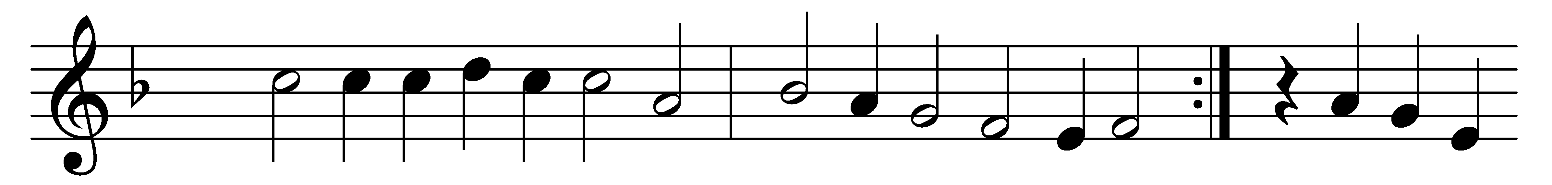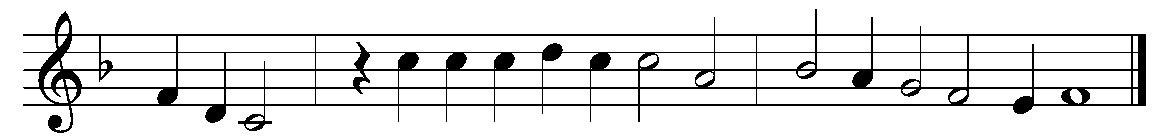

Lo, how a Rose e’er blooming
from tender stem hath sprung!
Of Jesse’s lineage coming
as seers of old have sung.
It came, a blossom bright,
amid the cold of winter,
when half spent was the night.

Isaiah ’twas foretold it,
the Rose I have in mind,
with Mary we behold it,
the Virgin Mother kind.
To show God’s love aright,
she bore to us a Savior,
when half spent was the night.

O Flower, whose fragrance tender
with sweetness fills the air,
dispel in glorious splendor
the darkness everywhere;
true man, yet very God,
from sin and death now save us,
and share our every load.

Words: vv. 1-2 German, 15th century, translated by Theodore Baker (1851-1934); v. 3 Friedrich Layritz (1808-1859), translated by Harriet Reynolds Krauth Spaeth (1845-1925)
Music: Melody from Alte Catholische Geistliche Kirchengesang, 1599, harmonised by Michael Praetorius (1571-1621)

