The King shall come when morning dawns Hymnal 1982 no. 73 Melody: St. Stephen C.M.

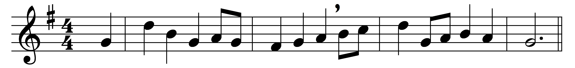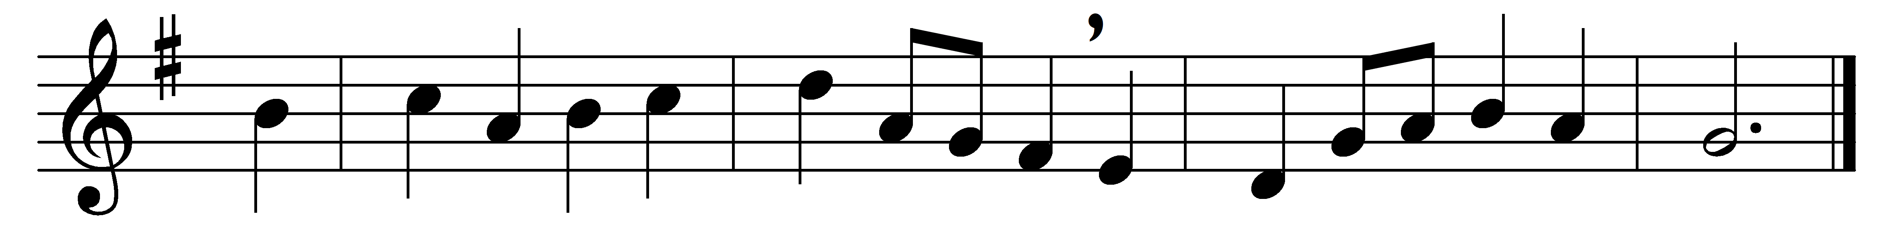

The King shall come when morning dawns
and light triumphant breaks;
when beauty gilds the eastern hills
and life to joy awakes.

Not, as of old, a little child,
to bear, and fight, and die,
but crowned with glory like the sun
that lights the morning sky.

The King shall come when morning dawns
and earth’s dark night is past;
O haste the rising of that morn,
the day that e’er shall last;

and let the endless bliss begin,
by weary saints foretold,
when right shall triumph over wrong,
and truth shall be extolled.

The King shall come when morning dawns
and light and beauty brings:
Hail, Christ the Lord! Thy people pray,
come quickly, King of kings.

Words: Greek, translated by John Brownlie (1859-1925)
Music: William Jones (1726-1800)

