O say can you see by the dawn’s early light Hymnal 1982 no. 720
Melody: National Anthem Irregular metre
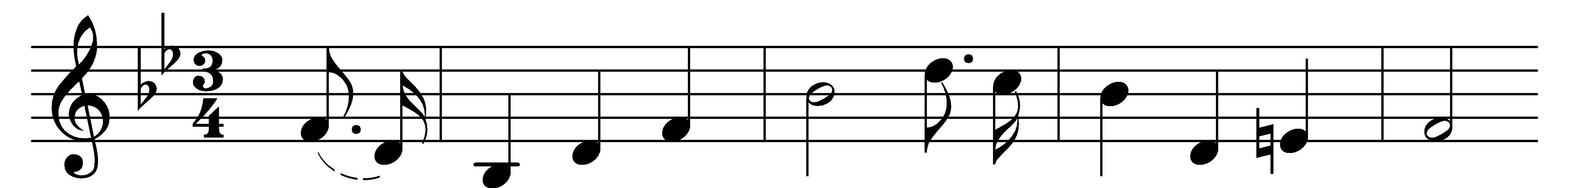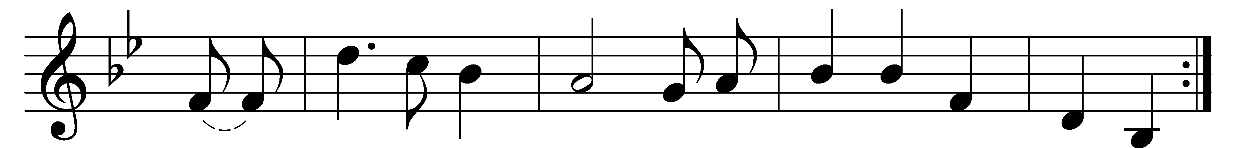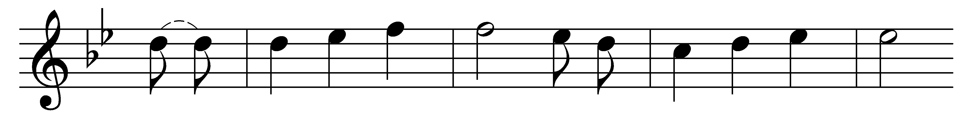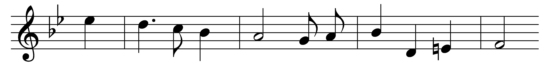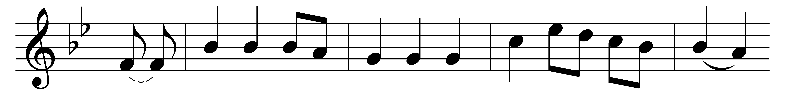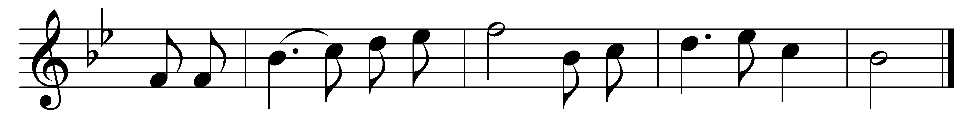

O say can you see, by the dawn’s early light,
what so proudly we hailed at the twilight’s last gleaming,
whose broad stripes and bright stars, through the perilous fight,
o’er the ramparts we watched, were so gallantly streaming?
And the rockets’ red glare, the bombs bursting in air,
gave proof through the night that our flag was still there.
O say does the star-spangled banner yet wave
o’er the land of the free and the home of the brave?

O thus be it ever, when free men shall stand
between their loved homes and the war’s desolation!
Blest with victory and peace, may the heaven-rescued land
praise the Power that hath made and preserved us a nation!
Then conquer we must, when our cause it is just,
and this be our motto, ‘In God is our trust.’
And the star-spangled banner in triumph shall wave
o’er the land of the free and the home of the brave!

Words: Francis Scott Key (1779-1843)
Music: Anonymous, c. 18th century

