God bless our native land Hymnal 1982 no. 716 Melody: America 6 6 4. 6 6 6 4.
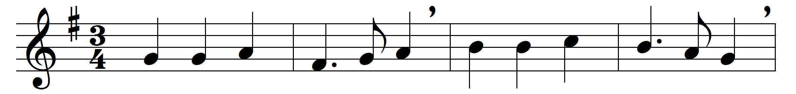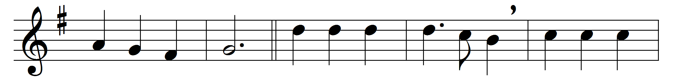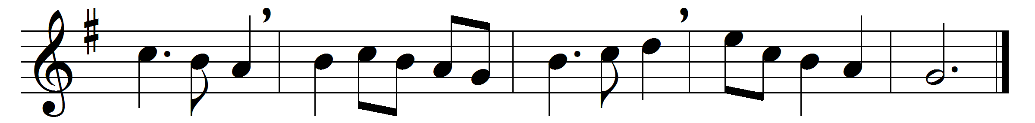

God bless our native land;
firm may she ever stand
through storm and night:
when the wild tempests rave,
ruler of wind and wave,
do thou our country save
by thy great might.

For her our prayers shall rise
to God, above the skies;
on him we wait;
thou who art ever nigh,
guarding with watchful eye,
to thee aloud we cry,
God save the state!

Words: Siegfried August Mahlmann (1771-1826), translated by Charles Timothy Brooks (1813-1883) and John Sullivan Dwight (1812-1893)
Music: Thesaurus Musicus, c. 1743

