When Jesus wept, the falling tear Hymnal 1982 no. 715 Melody: When Jesus wept L.M.
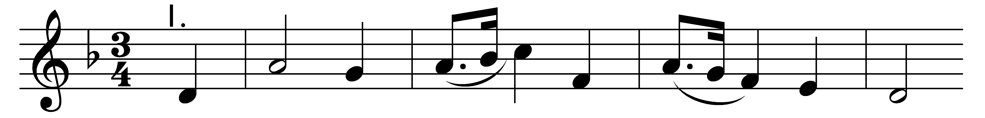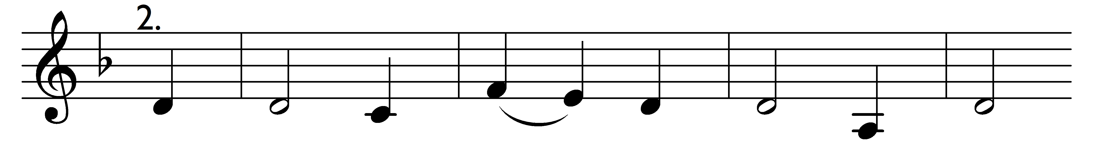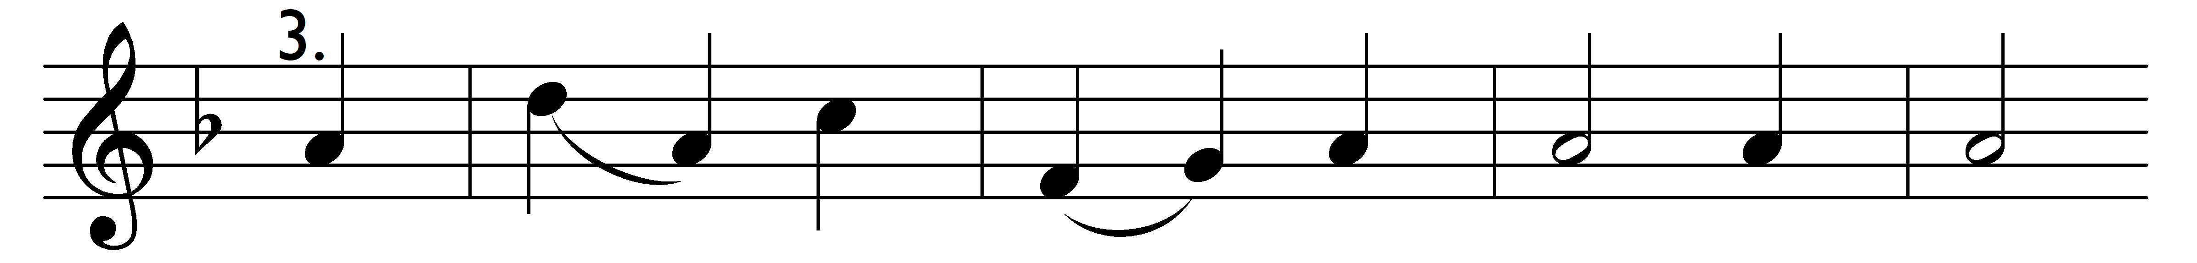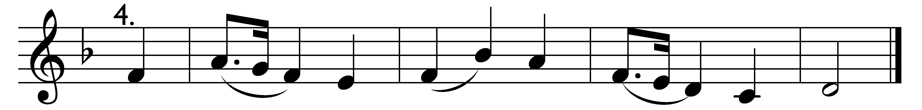

When Jesus wept, the falling tear
in mercy flowed beyond all bound;
when Jesus groaned, a trembling fear
seized all the guilty world around.

Words: The New England Psalm Singer, 1770
Music: William Billings (1746-1800)

