Shalom, my friends Hymnal 1982 no. 714 Melody: Shalom chaverim Irregular metre
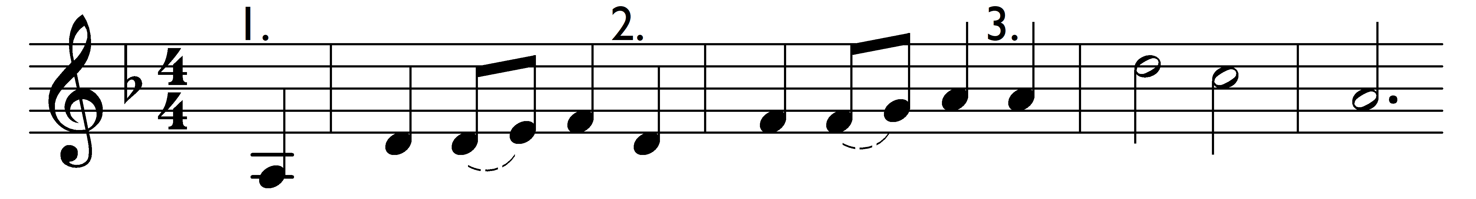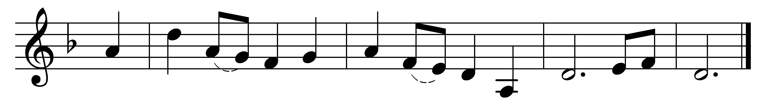

Shalom, my friends, shalom, my friends, shalom, shalom. (2x)
Shalom chaverim, shalom chaverim, shalom, shalom. (2x)

Words: Traditional
Music: Traditional

