Dona nobis pacem Hymnal 1982 no. 712 Melody: Dona nobis pacem Irregular metre
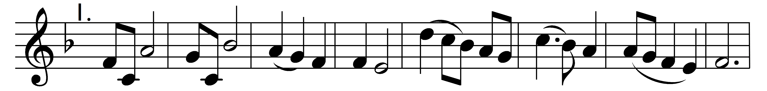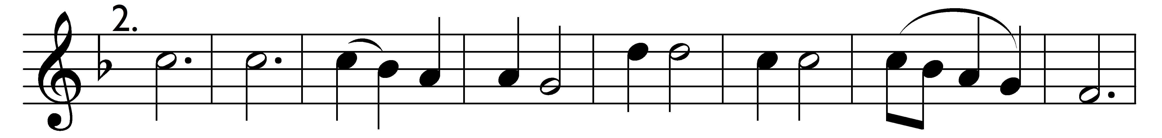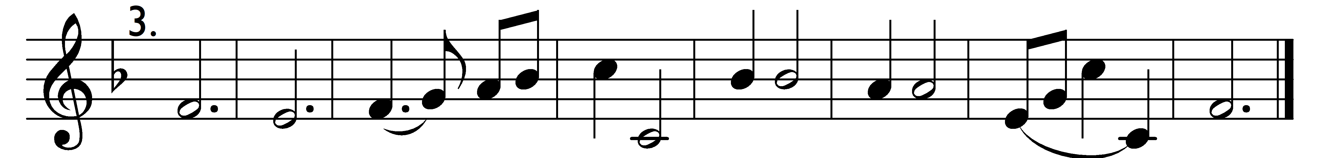

Dona nobis pacem.

Words: Traditional
Music: Traditional

