O God of Bethel, by whose hand Hymnal 1982 no. 709 Melody: Dundee C.M.
Words from AMNS
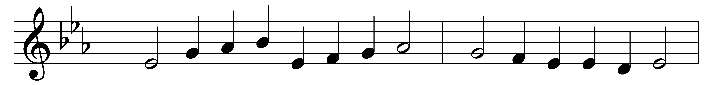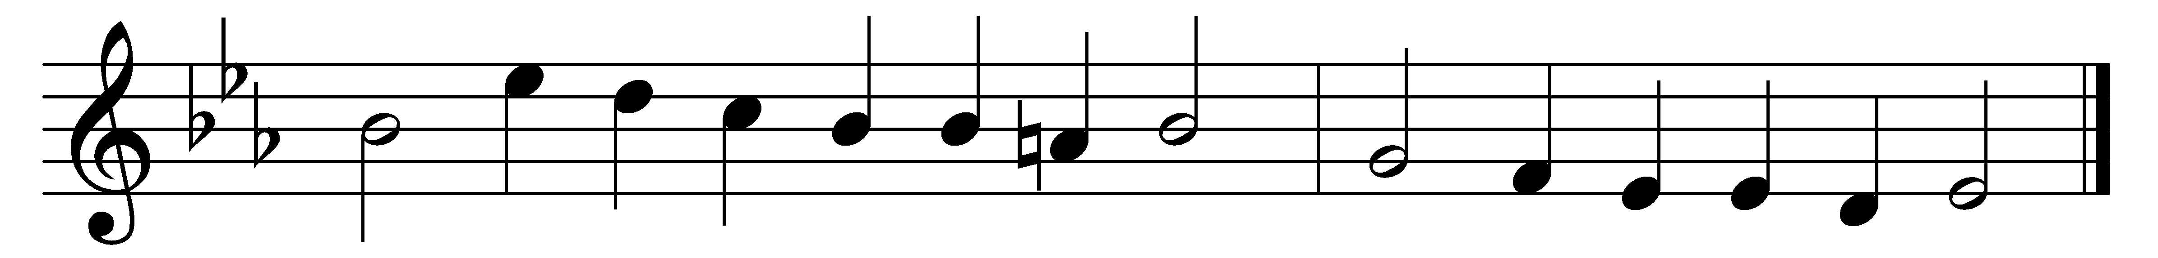

O God of Bethel, by whose hand
thy people still are fed,
who through this weary pilgrimage
hast all our fathers led;

our vows, our prayers, we now present
before thy throne of grace;
God of our fathers, be the God
of their succeeding race.

Through each perplexing path of life
our wandering footsteps guide;
give us each day our daily bread,
and raiment fit provide.

O spread thy covering wings around,
till all our wanderings cease,
and at our Father’s loved abode
our souls arrive in peace.

Words: Philip Doddridge (1702-1751)
Music: Melody from Psalms (Edinburgh, 1615), harmony by Thomas Ravenscroft (1592?-1635?)

