Saviour, like a shepherd, lead us Hymnal 1982 no. 708 Melody: Sicilian Mariners 8 7. 8 7. 8 7.
British spelling
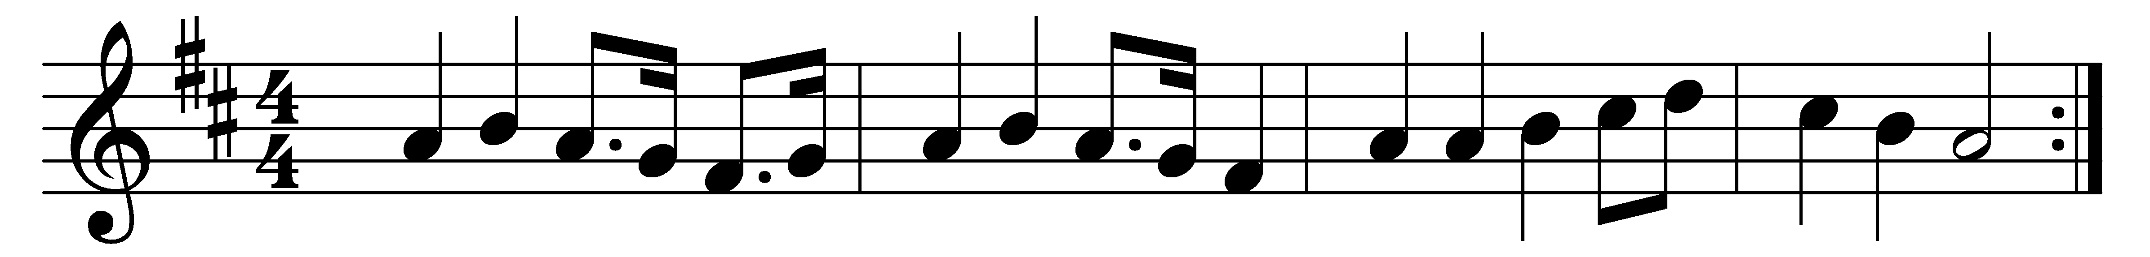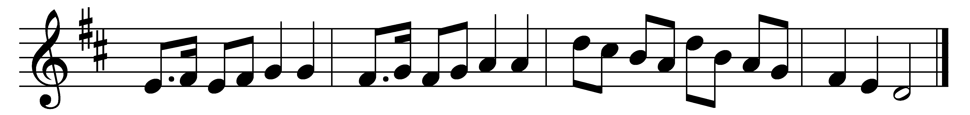

Saviour, like a shepherd lead us;
much we need thy tender care;
in thy pleasant pastures feed us;
for our use thy folds prepare.
Blessèd Jesus! Blessèd Jesus!
Thou hast bought us, thine we are.

Early let us seek thy favour,
early let us learn thy will;
do thou, Lord, our only Saviour,
with thy love our bosoms fill.
Blessèd Jesus! Blessèd Jesus!
Thou hast loved us: love us still.

Words: From Hymns for the Young, c. 1830
Music: Sicilian melody, first published in The European Magazine and London Review, 1792

