Take my life, and let it be Hymnal 1982 no. 707 Melody: Aberystwyth 7 7. 7 7. D.
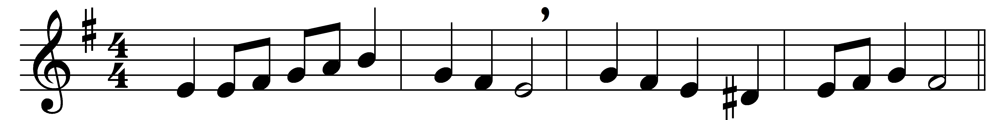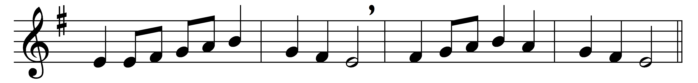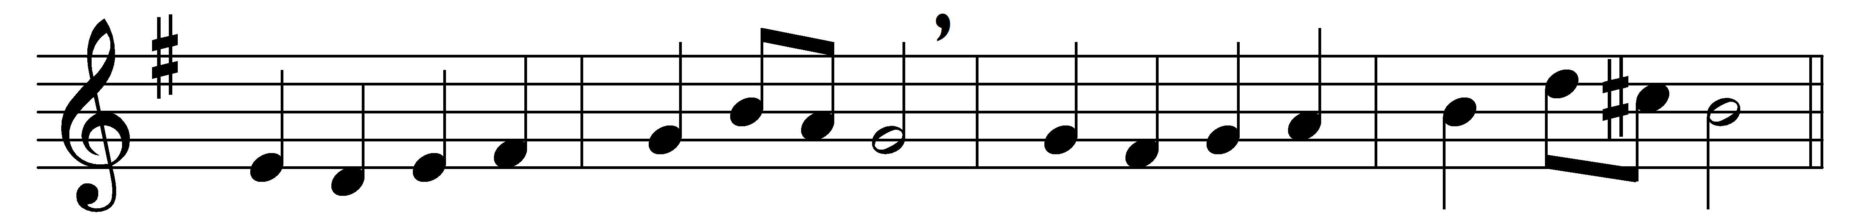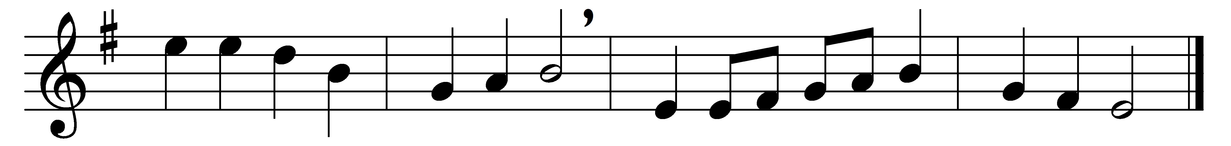

Take my life, and let it be
consecrated, Lord, to thee;
take my moments and my days,
let them flow in ceaseless praise.
Take my hands, and let them move
at the impulse of thy love;
take my heart, it is thine own;
it shall be thy royal throne.

Take my voice, and let me sing
always, only, for my King;
Take my intellect, and use
every power as thou shalt choose.
Take my will and make it thine;
it shall be no longer mine.
Take myself, and I will be
ever, only, all for thee.

Words: Frances Ridley Havergal (1836-1879)
Music: Joseph Parry (1841-1903)

