Lead us, O Father Hymnal 1982 no. 703 Melody: Song 22 10 10. 10 10.
British spelling
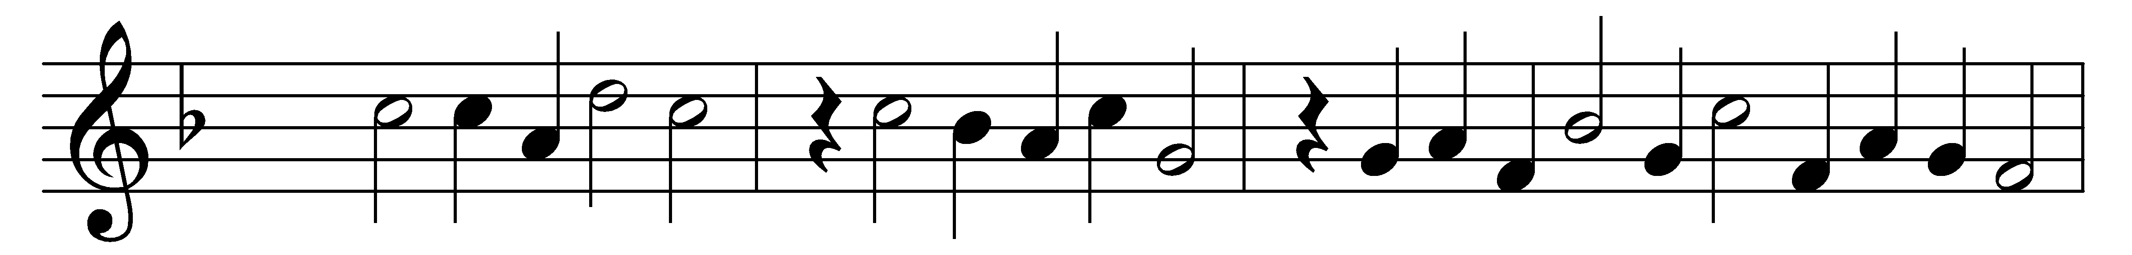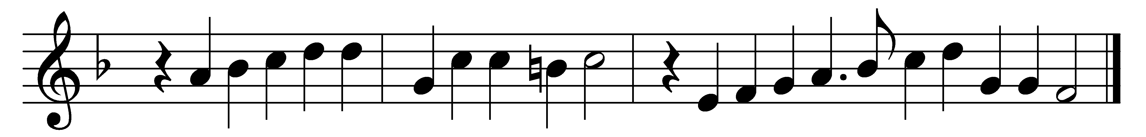

Lead us, O Father, in the paths of peace;
without thy guiding hand we go astray,
and doubts appal, and sorrows still increase;
lead us through Christ, the true and living Way.

Lead us, O Father, in the paths of right;
blindly we stumble when we walk alone,
involved in shadows of a darksome night;
only with thee we journey safely on.

Lead us, O Father, to thy heavenly rest,
however rough and steep the path may be;
through joy or sorrow, as thou deemest best,
until our lives are perfected in thee.

Words: William Henry Burleigh (1812-1871)
Music: Melody and bass by Orlando Gibbons (1583-1625)

