Jesus, all my gladness Hymnal 1982 no. 701 Melody: Jesu, meine Freude 6 6 5. 6 6 5. 7 8 6.
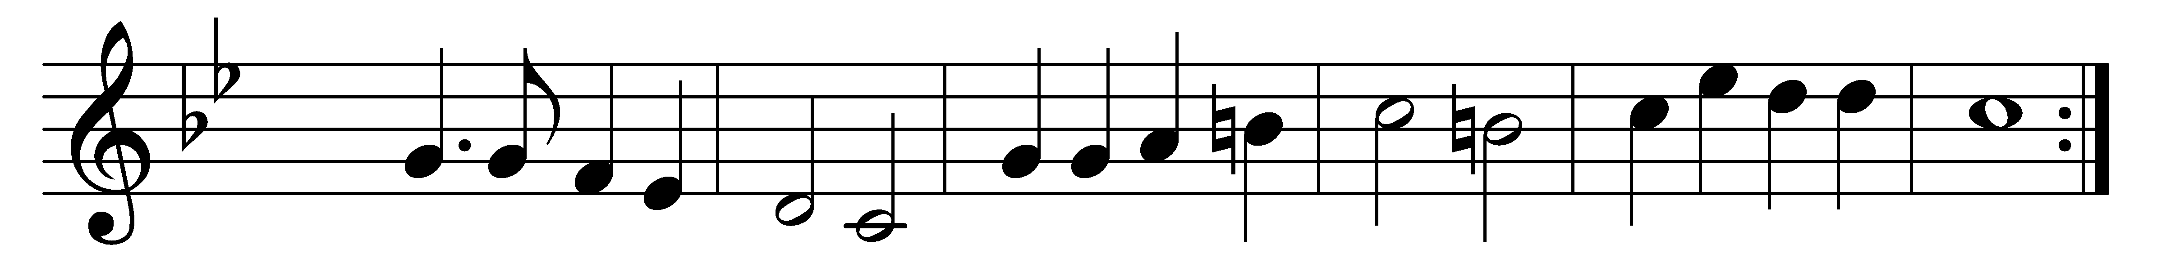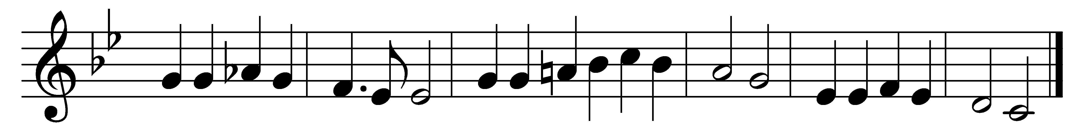

Jesus, all my gladness,
my repose in sadness,
Jesus, heaven to me;
ah, my heart long plaineth,
ah, my spirit straineth,
longeth after thee!
Thine I am, O holy Lamb;
only where thou art is pleasure,
thee alone I treasure.

Hence with earthly treasure:
thou art all my pleasure,
Jesus, my desire!
Hence, for pomps I care not,
e’en as though they were not
rank and fortune’s hire.
Want and gloom, cross, death, and tomb;
nought that I may suffer ever
shall from Jesus sever.

Flee, dark clouds that lower,
for my joy-bestower,
Jesus, enters in!
Joy from tribulation,
hope from desolation,
they who love God win.
Be it blame or scorn or shame,
thou art with me in earth’s sadness,
Jesus, all my gladness.

Words: Johann Franck (1618-1677), translated by Arthur Wellesley Wotherspoon (1853-1936)
Music: Johann Crüger (1598-1662)

