O love that casts our fear Hymnal 1982 no. 700 Melody: Moseley 6 6. 6 6.
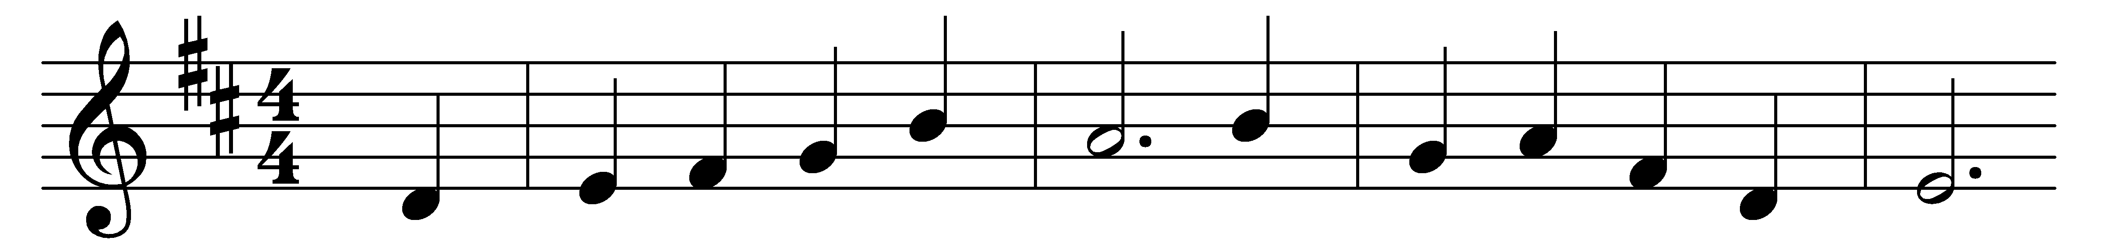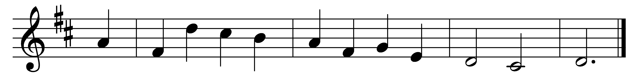

O love that casts out fear,
O love that casts out sin,
tarry no more without,
but come and dwell within.

True sunlight of the soul,
surround us as we go;
so shall our way be safe,
our feet no straying know.

Great love of God, come in!
Well-spring of heavenly peace;
thou Living Water, come!
Spring up, and never cease.

Love of the living God,
of Father and of Son;
love of the Holy Ghost,
fill thou each needy one.

Words: Horatius Bonar (1808-1889)
Music: Henry Thomas Smart (1813-1879)

