God be in my head Hymnal 1982 no. 694 Melody: Lytlington Irregular metre
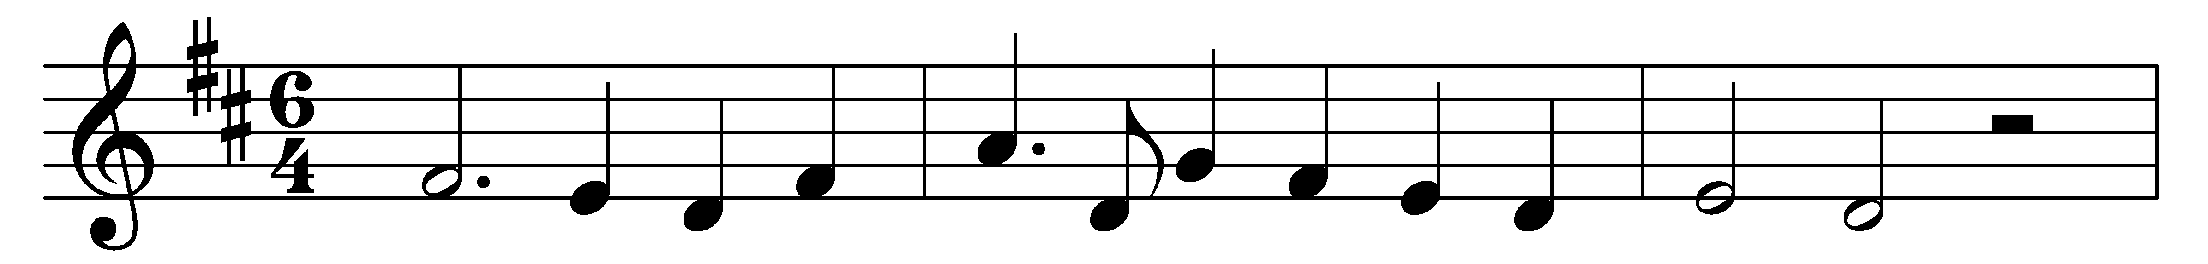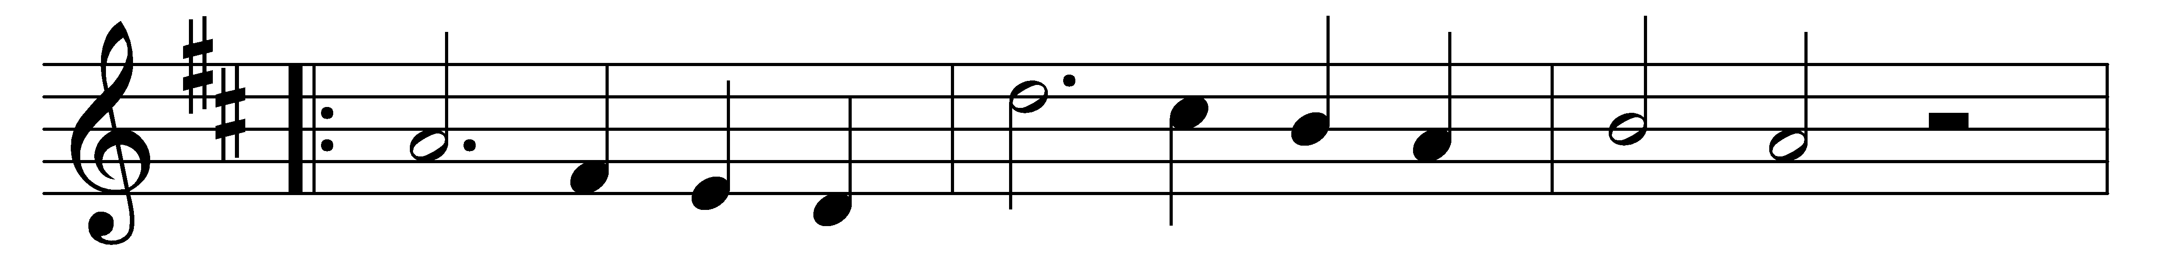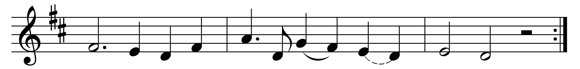

God be in my head,
and in my understanding;

God be in mine eyes,
and in my looking;

God be in my mouth,
and in my speaking;

God be in my heart,
and in my thinking;

God be at mine end,
and at my departing.

Words: Richard Pynson’s Horae, 1514
Music: Sydney Hugo Nicholson (1875-1947)

