Just as I am, without one plea Hymnal 1982 no. 693 Melody: Woodworth L.M.
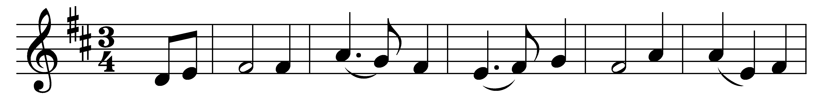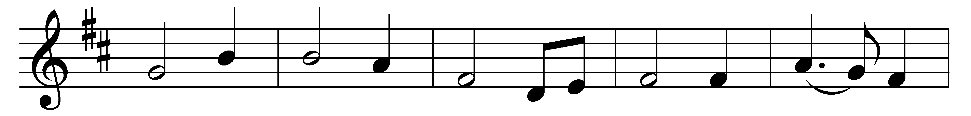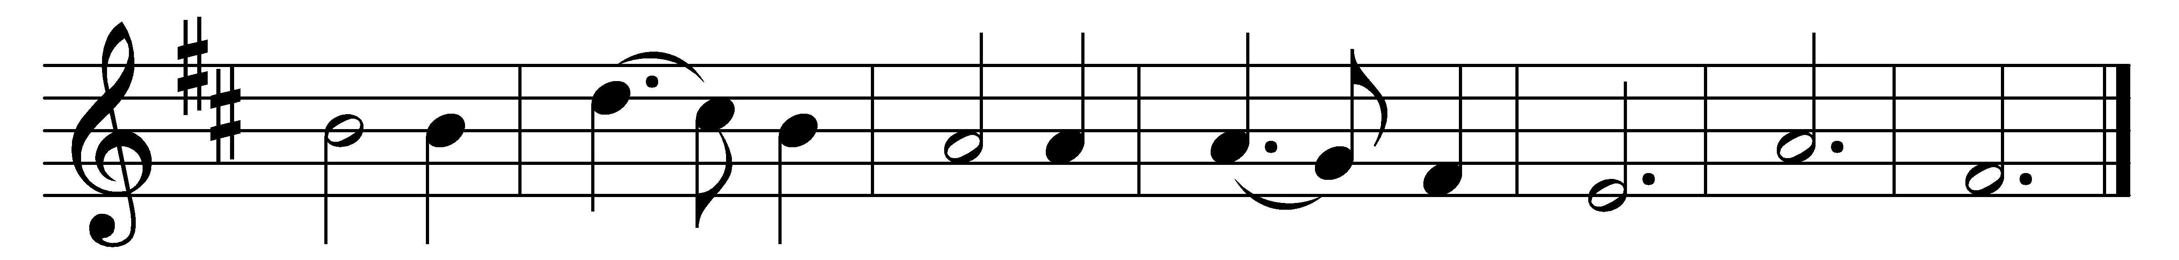

Just as I am, without one plea,
but that thy blood was shed for me,
and that thou bidd’st me come to thee,
O Lamb of God, I come, I come.

Just as I am, though tossed about
with many a conflict, many a doubt;
fightings and fears within, without,
O Lamb of God, I come, I come.

Just as I am, poor, wretched, blind;
sight, riches, healing of the mind,
yea, all I need, in thee to find,
O Lamb of God, I come, I come.

Just as I am: thou wilt receive;
wilt welcome, pardon, cleanse, relieve,
because thy promise I believe,
O Lamb of God, I come, I come.

Just as I am, thy love unknown
has broken every barrier down;
now to be thine, yea, thine alone,
O Lamb of God, I come, I come.

Just as I am, of thy great love
the breadth, length, depth, and height to prove,
here for a season, then above:
O Lamb of God, I come, I come.

Words: Charlotte Elliott (1789-1871)
Music: William Batchelder Bradbury (1816-1868)

