My faith looks up to thee Hymnal 1982 no. 691 Melody: Olivet 6 6 4. 6 6. 6 4.
British spelling

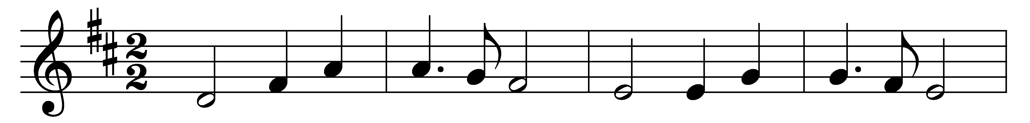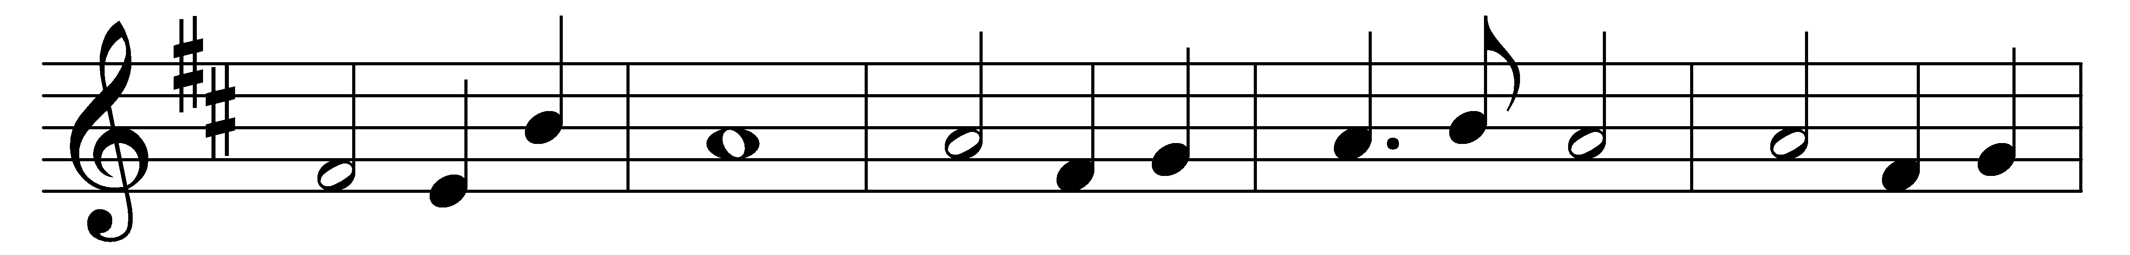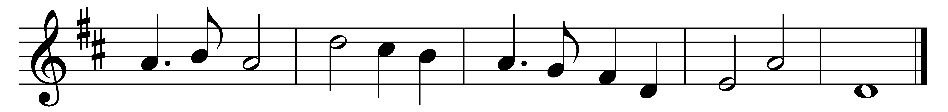

My faith looks up to thee,
thou Lamb of Calvary,
Saviour divine!
Now hear me while I pray,
take all my guilt away;
O let me from this day
be wholly thine.

May thy rich grace impart
strength to my fainting heart,
my zeal inspire;
as thou hast died for me,
O may my love to thee
pure, warm and changeless be,
a living fire.

While life’s dark maze I tread,
and griefs around me spread,
be thou my guide;
bid darkness turn to day;
wipe sorrow’s tears away,
nor let me ever stray
from thee aside.

Words: Ray Palmer (1808-1887)
Music: Lowell Mason (1782-1872)

