Rejoice! rejoice, believers Hymnal 1982 no. 68 Melody: Llangloffan 7 6. 7 6. D.
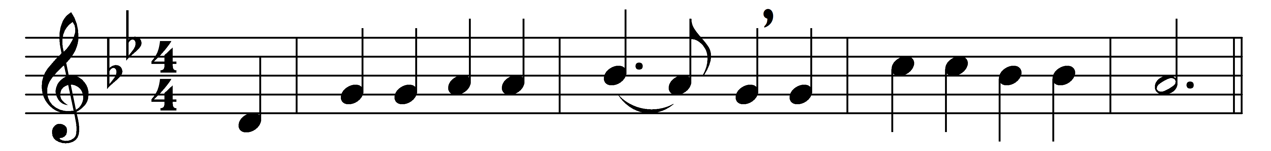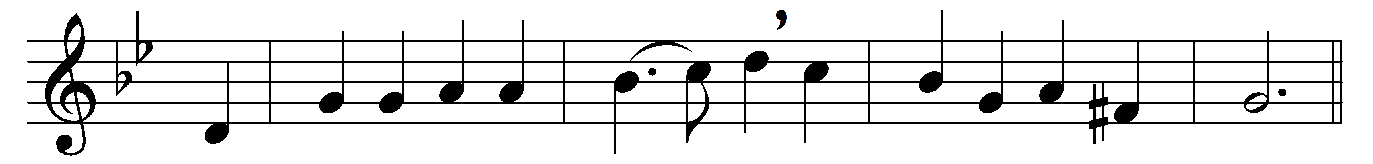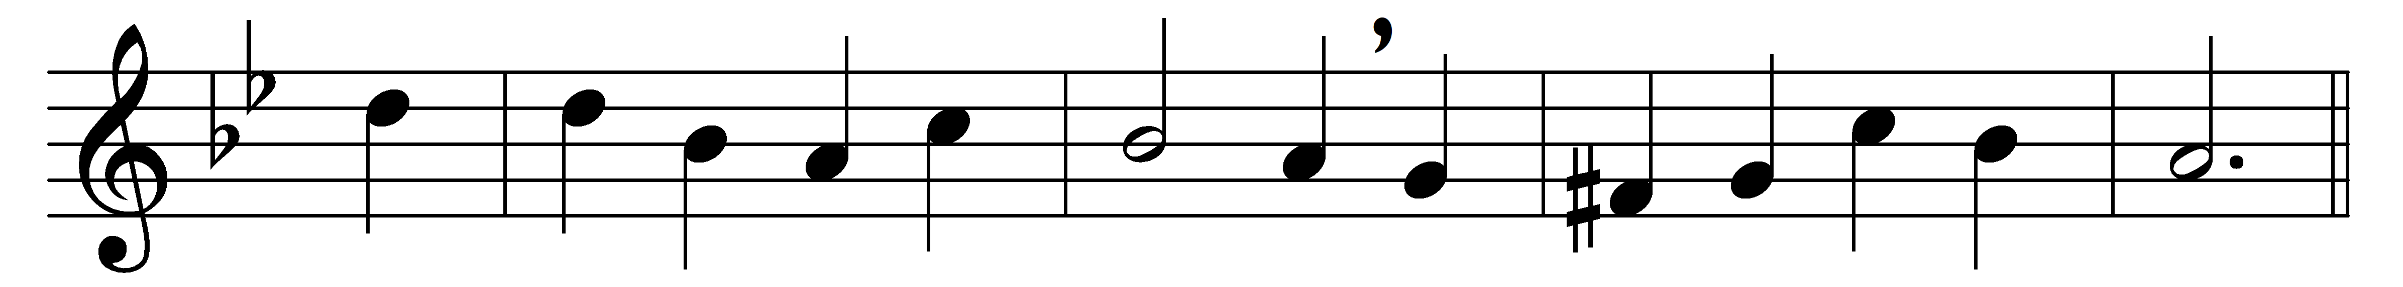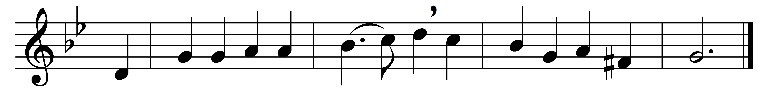

Rejoice! rejoice, believers,
and let your lights appear!
The evening is advancing,
and darker night is near.
The Bridegroom is arising,
and soon he will draw nigh;
up, watch in expectation!
at midnight comes the cry.

See that your lamps are burning,
replenish them with oil;
look now for your salvation,
the end of sin and toil.
The marriage-feast is waiting,
the gates wide open stand;
rise up, ye heirs of glory,
the Bridegroom is at hand!

Our hope and expectation,
O Jesus, now appear;
arise, thou Sun so longed for,
above this darkened sphere!
With hearts and hands uplifted,
we plead, O Lord, to see
the day of earth’s redemption,
and ever be with thee!

Words: Laurentius Laurenti (1660-1722), translated by Sarah Laurie Borthwick Findlater (1823-1907)
Music: Melody from Hymnau a Thonau er Gwasanaeth yr Eglwys yng Nghymru (1865)

