A mighty fortress is our God Hymnal 1982 no. 687
Melody: Ein’ feste Burg 8 7. 8 7. 6 6. 6 6 7.
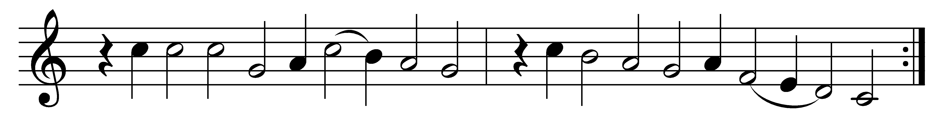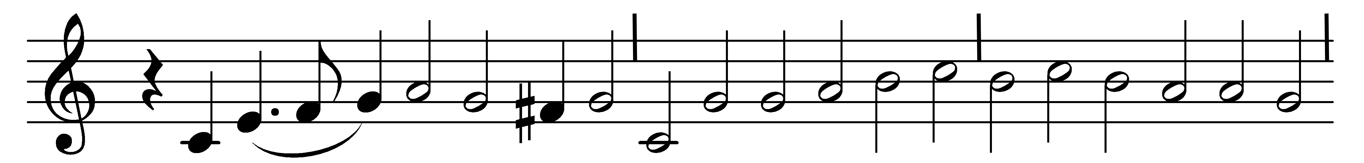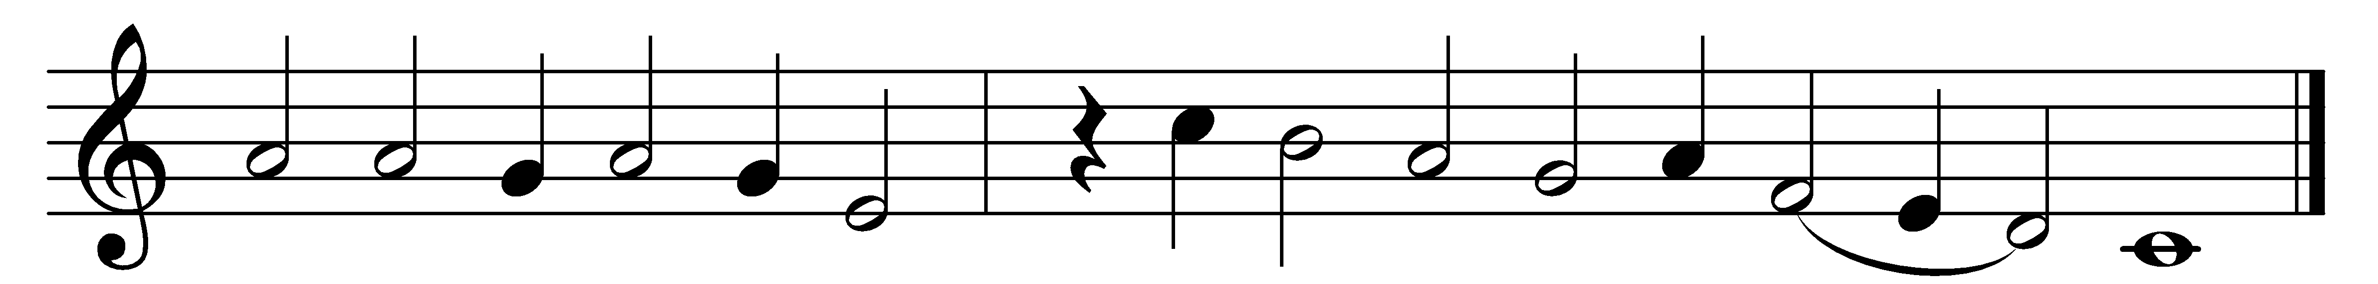

A mighty fortress is our God,
a bulwark never failing;
our helper he, amid the flood
of mortal ills prevailing:
for still our ancient foe
doth seek to work us woe;
his craft and power are great,
and, armed with cruèl hate,
on earth is not his equal.

Did we in our strength confide,
our striving would be losing;
were not the right man on our side,
the man of God’s own choosing:
dost ask who that may be?
Christ Jesus, it is he;
Lord Sabaoth his Name,
from age to age the same,
and he must win the battle.

And though this world, with devils filled,
should threaten to undo us,
we will not fear, for God hath willed
his truth to triumph through us;
the prince of darkness grim,
we tremble not for him;
his rage we can endure,
for lo! his doom is sure,
one little word shall fell him.

That word above all earthly powers,
no thanks to them, abideth;
the Spirit and the gifts are ours
through him who with us sideth:
let goods and kindred go,
this mortal life also;
the body they may kill:
God’s truth abideth still,
his kingdom is for ever.

Words: Martin Luther (1483-1546), translated by Frederic Henry Hedge (1805-1890)
Music: Melody by Martin Luther (1483-1546), harmony by Hans Leo Hassler (1564-1612)

