Rock of ages, cleft for me Hymnal 1982 no. 685 Melody: Toplady 7 7. 7 7. 7 7.
Words from AMNS
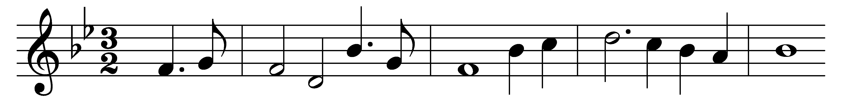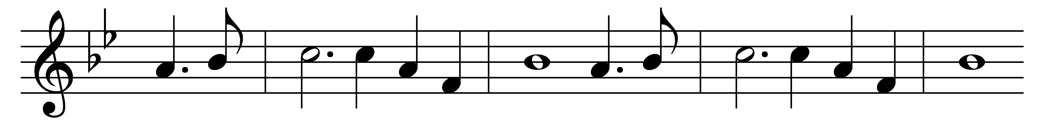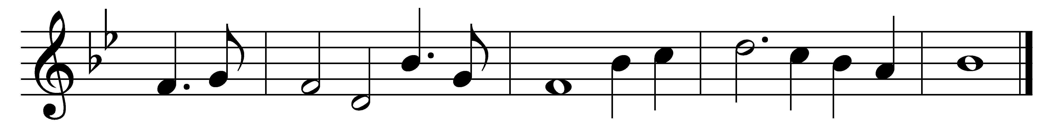

Rock of ages, cleft for me,
let me hide myself in thee;
let the water and the blood,
from thy riven side which flowed,
be of sin the double cure:
cleanse me from its guilt and power.
Not the labours of my hands
can fulfil thy law’s demands;
could my zeal no respite know,
could my tears for ever flow,
all for sin could not atone:
thou must save, and thou alone.
Nothing in my hand I bring,
simply to thy cross I cling;
naked, come to thee for dress;
helpless, look to thee for grace;
foul, I to the fountain fly;
wash me, Saviour, or I die.
While I draw this fleeting breath,
when my eyelids close in death,
when I soar through tracts unknown,
see thee on thy judgement throne;
Rock of ages, cleft for me,
let me hide myself in thee.

Words: Augustus Montague Toplady (1740-1778)
Music: Thomas Hastings (1784-1872)

