Rock of ages, cleft for me Hymnal 1982 no. 685 Melody: Toplady 7 7. 7 7. 7 7.
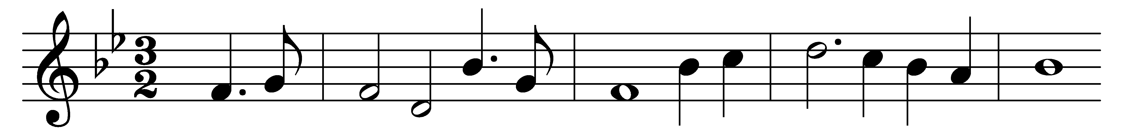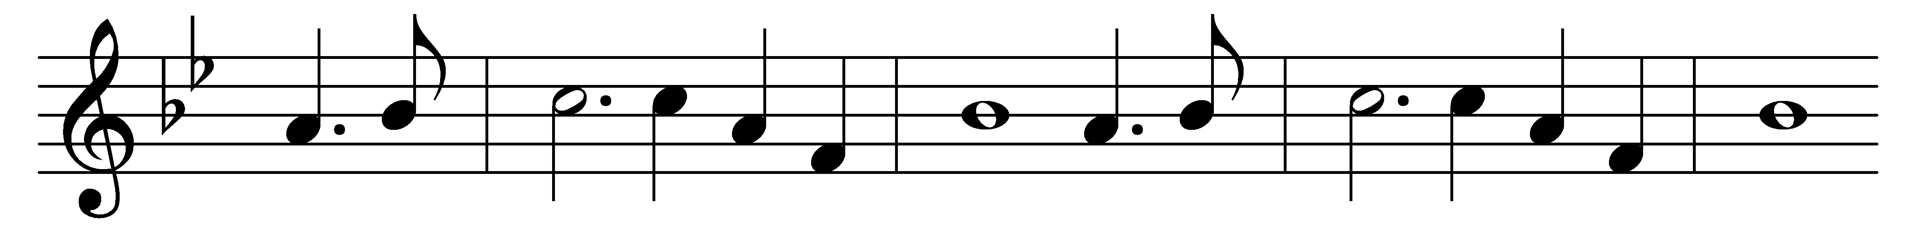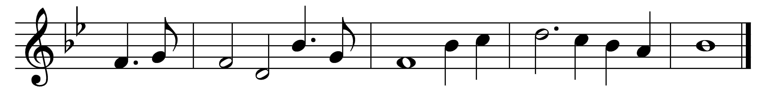

Rock of ages, cleft for me,
let me hide myself in thee;
let the water and the blood
from thy wounded side which flowed,
be of sin the double cure,
cleanse me from its guilt and power.

Should my tears for ever flow,
should my zeal no languor know,
all for sin could not atone:
thou must save, and thou alone;
in my hand no price I bring,
simply to thy cross I cling.

While I draw this fleeting breath,
when mine eyelids close in death,
when I rise to worlds unknown
and behold thee on thy throne,
Rock of ages, cleft for me,
let me hide myself in thee.

Words: Augustus Montague Toplady (1740-1778)
Music: Thomas Hastings (1784-1872)

