O for a closer walk with God Hymnal 1982 no. 683 Melody: Beatitudo C.M.
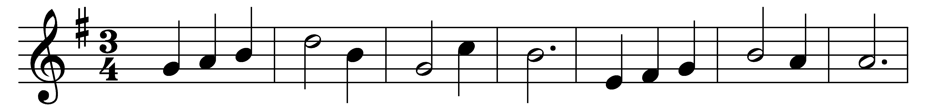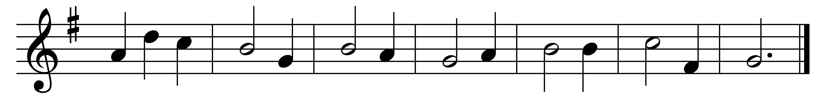

O for a closer walk with God,
a calm and heavenly frame,
a light to shine upon the road
that leads me to the Lamb!

Where is the blessedness I knew
when first I saw the Lord?
Where is the soul-refreshing view
of Jesus and his word?

Return, O holy Dove, return,
sweet messenger of rest;
I hate the sins that made thee mourn,
and drove thee from my breast.

The dearest idol I have known,
whate’er that idol be,
help me to tear it from thy throne,
and worship only thee.

So shall my walk be close with God,
calm and serene my frame;
so purer light shall mark the road
that leads me to the Lamb.

Words: William Cowper (1731-1800)
Music: John Bacchus Dykes (1823-1876)

