Our God, to whom we turn Hymnal 1982 no. 681
Melody: O Gott, du frommer Gott 6 7. 6 7. 6 6. 6 6.
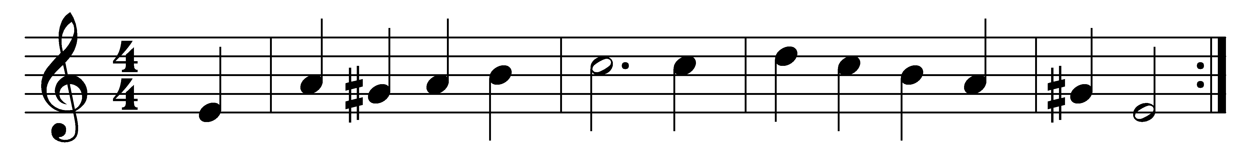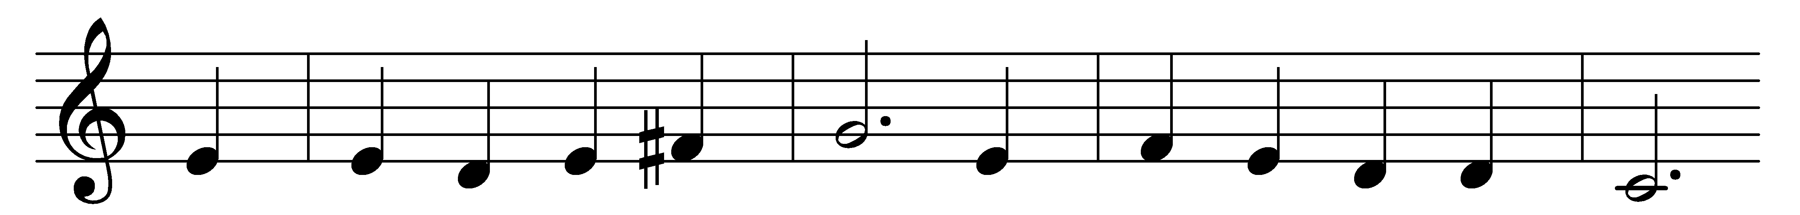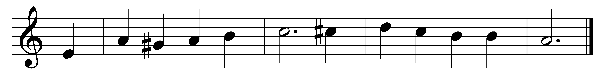

Our God, to whom we turn
when weary with illusion,
whose stars serenely burn
above this earth’s confusion,
thine is the mighty plan,
the steadfast order sure
in which the world began,
endures, and shall endure.

Thou art thyself the truth;
though we who seek to find thee
have tried, with thoughts uncouth,
in feeble words to bind thee,
it is because thou art
we’re driven to the quest;
till truth from falsehood part,
our hearts can find no rest.

All beauty speaks of thee:
the mountains and the rivers,
the line of lifted sea,
where spreading moonlight quivers,
the hymns thy people raise,
the psalms and anthems strong,
hint at the glorious praise
of thy eternal song.

Where goodness comes to light
we glimpse thy plan unfolding;
where justice wins its fight
thou art the Kingdom molding;
the blood of friend as sign
of love for comrade spilt,
reflects the vast design
by which thy house is built.

Thou hidden fount of love,
of peace, and truth, and beauty,
inspire us from above
with joy and strength for duty.
May thy fresh light arise
within each clouded heart,
and give us open eyes
to see thee as thou art.

Words: Edward Grubb (1854-1939)
Music: Melody from Neu ordentlich Gesangbuch, 1646, harmony by Johann Sebastian Bach (1685-1750)

