Comfort, comfort ye my people Hymnal 1982 no. 67 Melody: Psalm 42 8 7. 8 7. 7 7. 8 8.
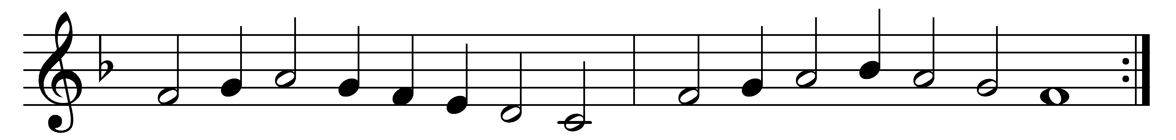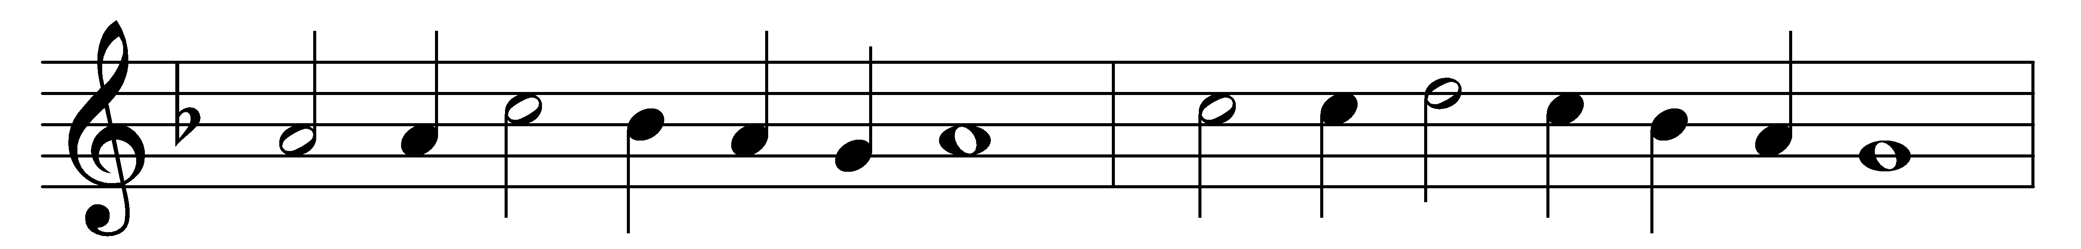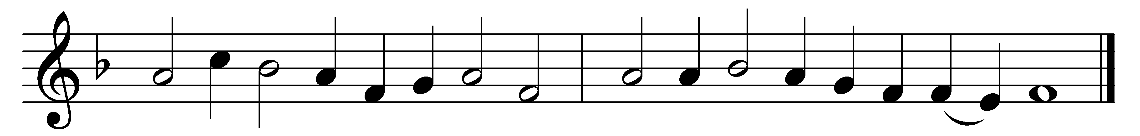

Comfort, comfort ye my people,
speak ye peace, thus saith our God;
comfort those who sit in darkness
mourning ’neath their sorrows’ load.
Speak ye to Jerusalem
of the peace that waits for them;
tell her that her sins I cover,
and her warfare now is over.

Hark, the voice of one that crieth
in the desert far and near,
calling us to new repentance
since the kingdom now is here.
Oh, that warning cry obey!
Now prepare for God a way;
let the valleys rise to meet him
and the hills bow down to greet him.

Make ye straight what long was crooked,
make the rougher places plain;
let your hearts be true and humble,
as befits his holy reign.
For the glory of the Lord
now o’er earth is shed abroad;
and all flesh shall see the token
that the word is never broken.

Words: Johann Olearius (1611-1684), translated by Catherine Winkworth (1827-1878)
Music: Melody by Claude Goudimel (1514-1572)

