There is a balm in Gilead Hymnal 1982 no. 676 Melody: Balm in Gilead Irregular metre
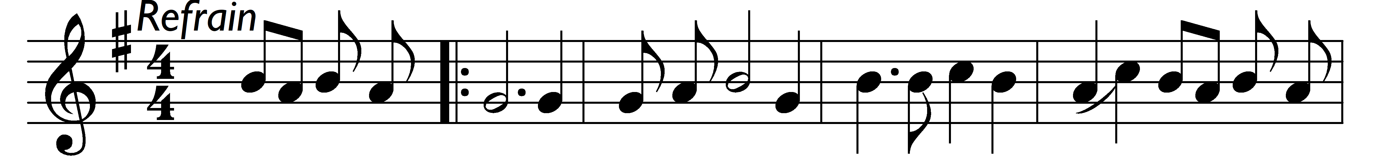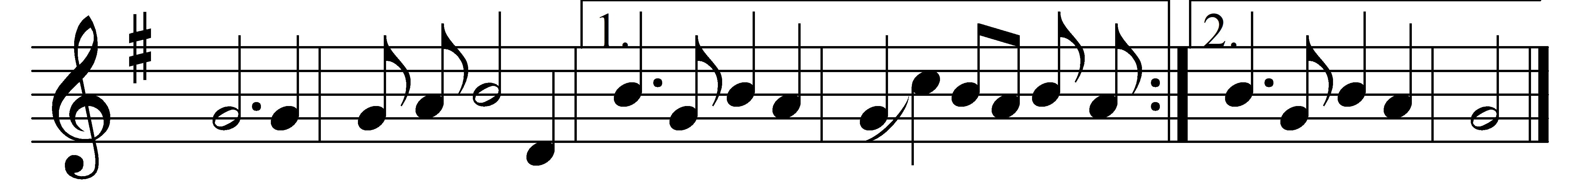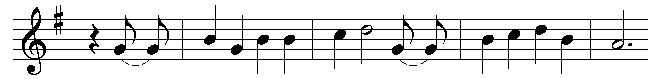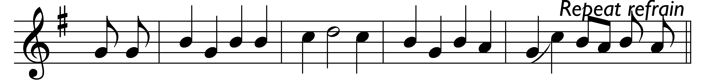

(Refrain:) There is a balm in Gilead,
to make the wounded whole,
there is a balm in Gilead
to heal the sin-sick soul. (sung twice)

Sometimes I feel discouraged.
and think my work’s in vain,
but then the Holy Spirit
revives my soul again. (Refrain)

If you cannot preach like Peter,
if you cannot pray like Paul,
you can tell the love of Jesus
and say, ‘He died for all.’ (Refrain)

Words: Afro-American spiritual
Music: Afro-American spiritual

