Take up your cross, the Savior said Hymnal 1982 no. 675 Melody: Bourbon L.M.
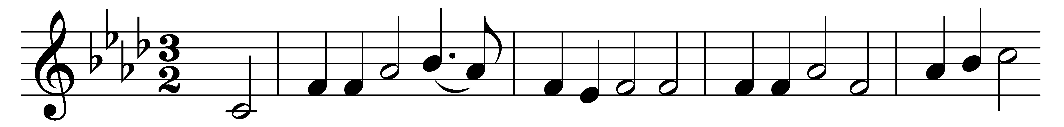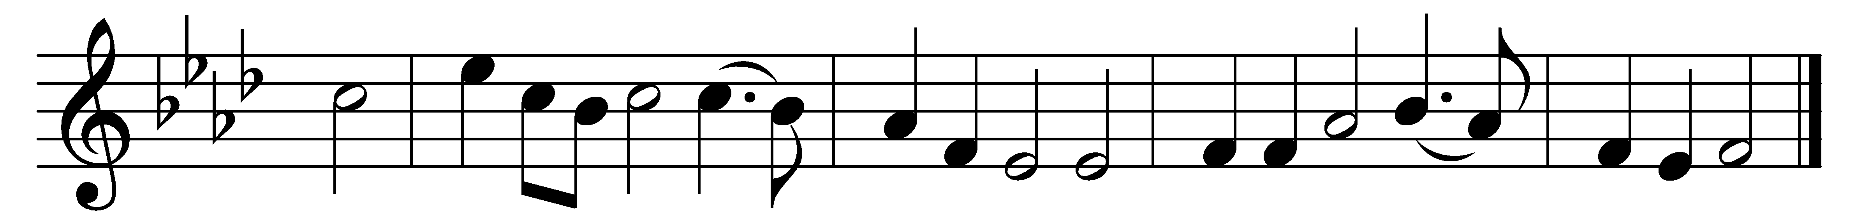

Take up your cross, the Savior said,
if you would my disciple be;
take up your cross with willing heart,
and humbly follow after me.

Take up your cross, let not its weight
fill your weak spirit with alarm;
his strength shall bear your spirit up,
and brace your heart, and nerve your arm.

Take up your cross, heed not the shame,
and let your foolish heart be still;
the Lord for you accepted death
upon a cross, on Calvary’s hill.

Take up your cross, then, in his strength,
and calmly every danger brave;
it guides you to abundant life
and leads to victory o’er the grave.

Take up your cross, and follow Christ,
nor think till death to lay it down;
for only those who bear the cross
may hope to wear the glorious crown.

Words: Charles William Everest (1814-1877)
Music: Melody attributed to Freeman Lewis (1780-1859)

