Come, thou long-expected Jesus Hymnal 1982 no. 66 Melody: Stuttgart 8 7. 8 7.

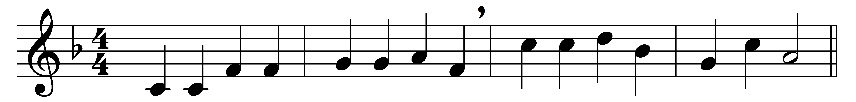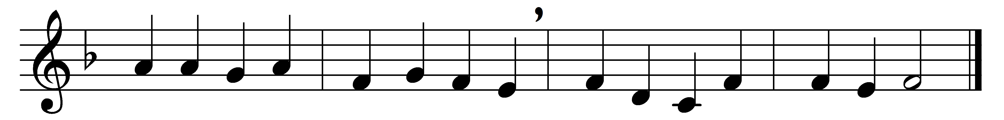

Come, thou long-expected Jesus,
born to set thy people free;
from our fears and sins release us,
let us find our rest in thee.

Israel’s strength and consolation,
hope of all the earth thou art:
dear desire of every nation,
joy of every longing heart.

Born thy people to deliver,
born a child, and yet a king,
born to reign in us for ever,
now thy gracious kingdom bring.

By thine own eternal Spirit
rule in all our hearts alone;
by thine all-sufficient merit
raise us to thy glorious throne.

Words: Charles Wesley (1707-1788)
Music: Adapted from a melody by Christian Friedrich Witt (1660-1716)

