O Master, let me walk with thee Hymnal 1982 no. 660 Melody: Maryton L.M.
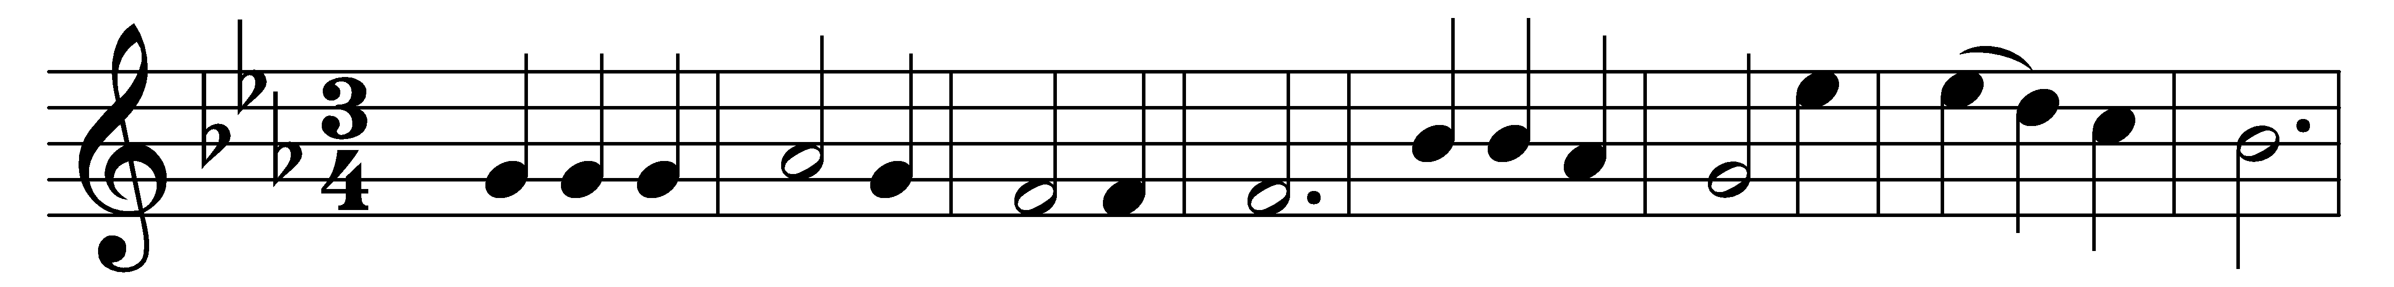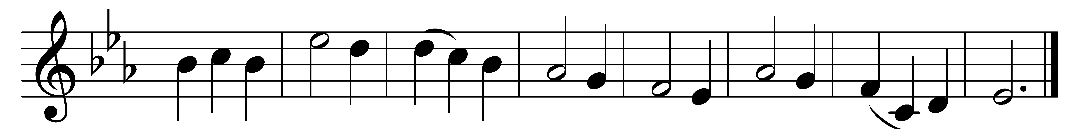

O Master, let me walk with thee
in lowly paths of service free;
tell me thy secret; help me bear
the strain of toil, the fret of care.

Help me the slow of heart to move
by some clear, winning word of love;
teach me the wayward feet to stay,
and guide them in the homeward way.

Teach me thy patience; still with thee
in closer, dearer company,
in work that keeps faith sweet and strong,
in trust that triumphs over wrong,

in hope that sends a shining ray
far down the future’s broadening way,
in peace that only thou canst give,
with thee, O Master, let me live.

Words: Washington Gladden (1836-1918)
Music: Henry Percy Smith (1825-1898)

