Dear Lord and Father of mankind Hymnal 1982 no. 652 Melody: Rest 8 6. 8 8 6.
Words from AMNS
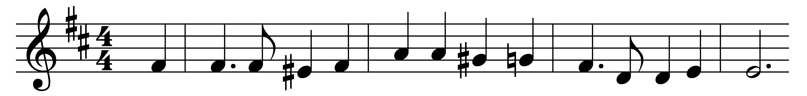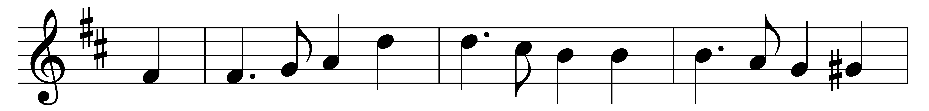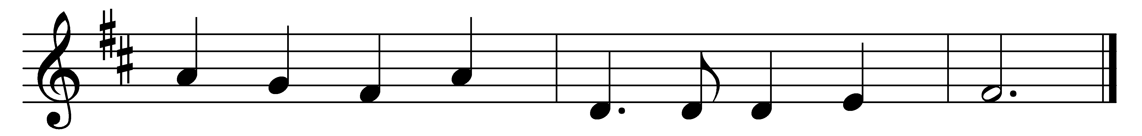

Dear Lord and Father of mankind,
forgive our foolish ways;
re-clothe us in our rightful mind,
in purer lives thy service find,
in deeper reverence praise.

In simple trust like theirs who heard,
beside the Syrian sea,
the gracious calling of the Lord,
let us, like them, without a word
rise up and follow thee.

O Sabbath rest by Galilee!
O calm of hills above,
where Jesus knelt to share with thee
the silence of eternity,
interpreted by love!

Drop thy still dews of quietness,
till all our strivings cease;
take from our souls the strain and stress,
and let our ordered lives confess
the beauty of thy peace.

Breathe through the heats of our desire
thy coolness and thy balm;
let sense be dumb, let flesh retire;
speak through the earthquake, wind, and fire,
O still small voice of calm.

Words: John Greenleaf Whittier (1807-1892)
Music: Frederick Charles Maker (1844-1927)

