My God, how wonderful thou art 1982 no. 643 Melody: Windsor C.M.
Rhythmic (melody from no. 642)
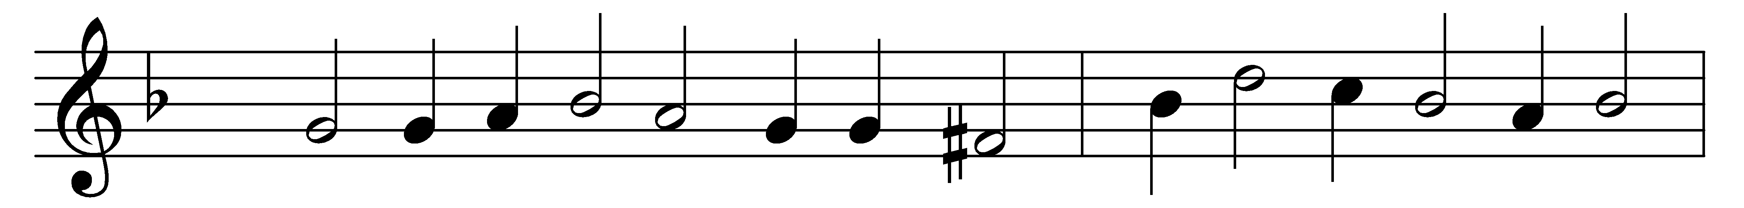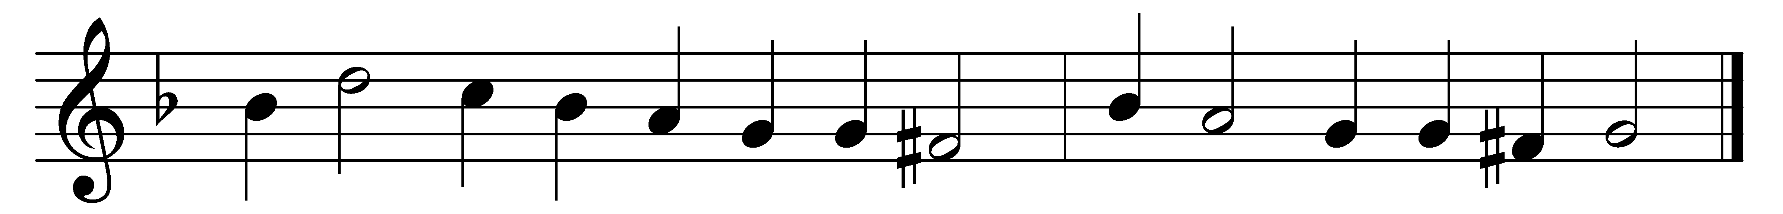

My God, how wonderful thou art,
thy majesty how bright,
how beautiful thy mercy seat,
in depths of burning light!

How dread are thine eternal years,
O everlasting Lord,
by prostrate spirits day and night
incessantly adored!

How wonderful, how beautiful,
the sight of thee must be,
thine endless wisdom, boundless power,
and aweful purity!

O how I fear thee, living God,
with deepest, tenderest fears,
and worship thee with trembling hope
and penitential tears!

Yet I may love thee too, O Lord,
almighty as thou art,
for thou hast stooped to ask of me
the love of my poor heart.

Words: Frederick William Faber (1814-1863)
Music: Melody by William Damon (1540?-1591?), harmony by Thomas Este (1540?-1608?)

