How firm a foundation, ye saints of the Lord Hymnal 1982 no. 637 Melody: Lyons 11 11. 11 11.
British spelling
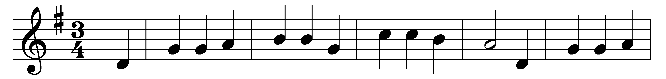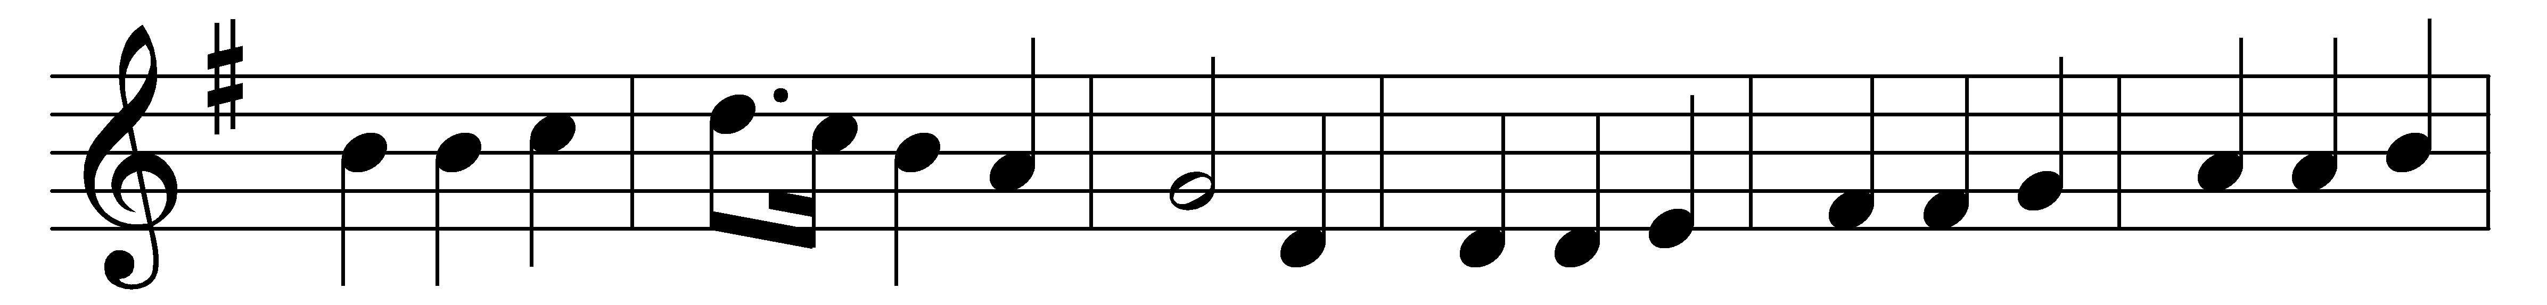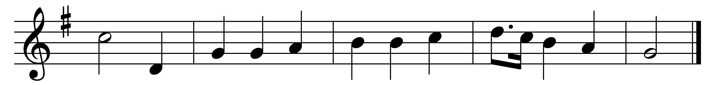

How firm a foundation, ye saints of the Lord,
is laid for your faith in his excellent word!
What more can he say than to you he hath said,
to you that for refuge to Jesus have fled?

‘Fear not, I am with thee; O be not dismayed!
For I am thy God, and will still give thee aid;
I’ll strengthen thee, help thee, and cause thee to stand,
upheld by my righteous, omnipotent hand.

‘When through the deep waters I call thee to go,
the rivers of woe shall not thee overflow;
for I will be with thee, thy troubles to bless,
and sanctify to thee thy deepest distress.

‘When through fiery trials thy pathway shall lie,
my grace, all sufficient, shall be thy supply;
the flame shall not hurt thee; I only design
thy dross to consume, and thy gold to refine.

‘The soul that to Jesus hath fled for repose,
I will not, I will not desert to its foes;
that soul, though all hell shall endeavour to shake,
I’ll never, no, never, no, never forsake.’

Words: K. in John Rippon’s Selection, 1787
Music: Attributed to Johann Michael Haydn (1737-1806)

