I call on thee, Lord Jesus Christ Hymnal 1982 no. 634 Melody: Ich ruf zu dir Irregular metre
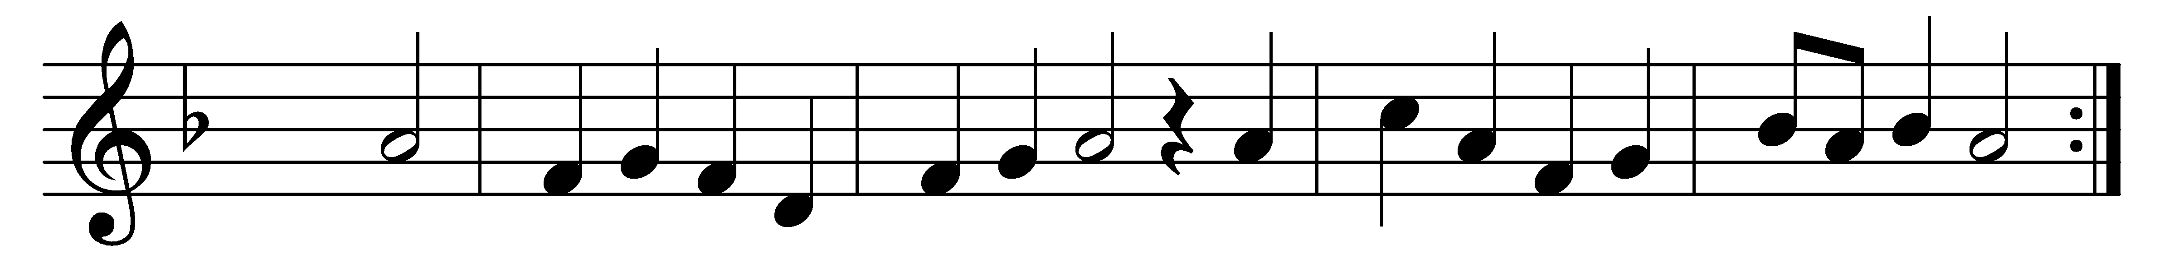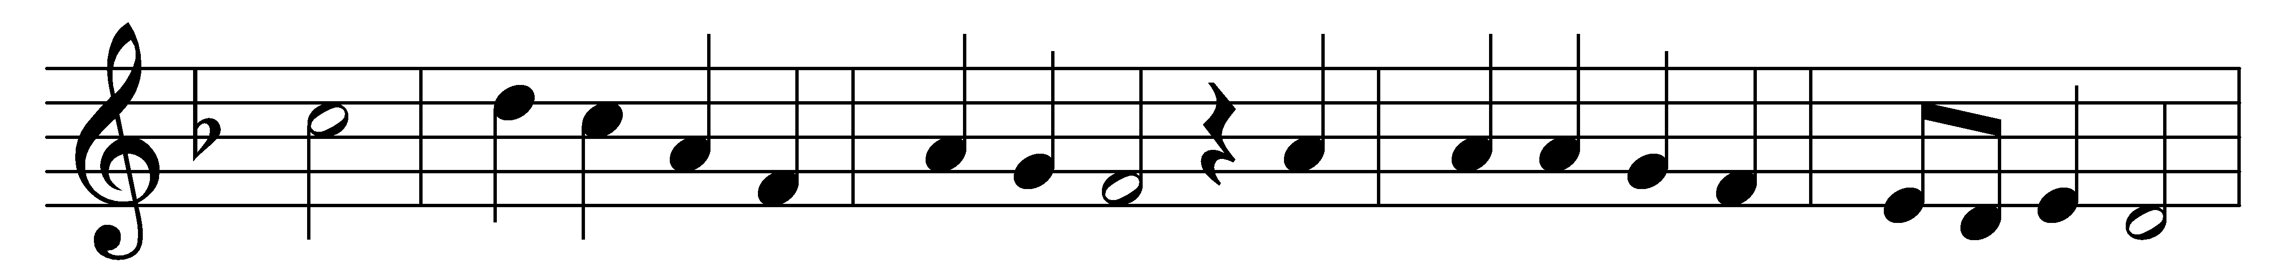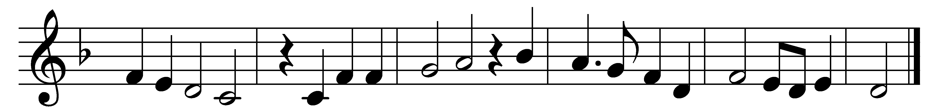

I call on thee, Lord Jesus Christ,
I have none other help but thee.
My heart is never set at rest
till thy sweet word have comforted me.
And steadfast faith grant me therefore,
to hold by thy word evermore,
above all thing, never resisting
but to increase in faith more and more.

Words: Miles Coverdale (1487-1568)
Music: From Geistliche Lieder, 1533; harmony from Thüringer Evangelisches Gesangbuch, 1928

