Book of books, our people’s strength Hymnal 1982 no. 631 Melody: Liebster Jesu 7 8. 7 8. 8 8.
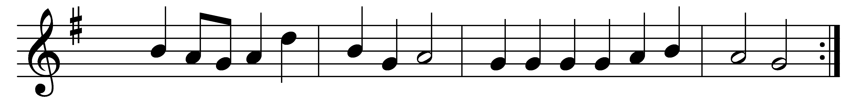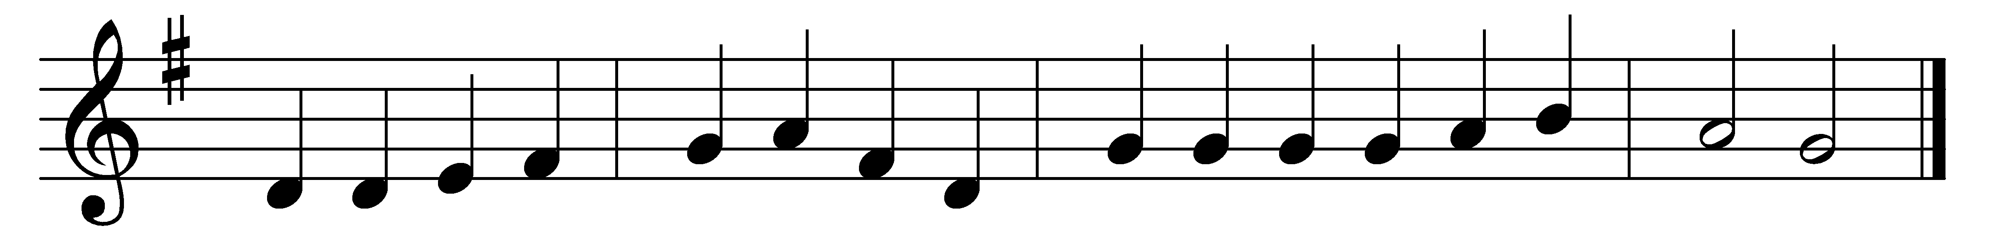

Book of books, our people’s strength,
statesman’s, teacher’s, hero’s treasure,
bringing freedom, spreading truth,
shedding light that none can measure:
wisdom comes to those who know thee,
all the best we have we owe thee.

Thank we those who toiled in thought,
many diverse scrolls completing,
poets, prophets, scholars, saints,
each a word from God repeating;
till they came, who told the story
of the Word, and showed his glory.

Praise we God, who hath inspired
those whose wisdom still directs us;
praise him for the Word made flesh,
for the Spirit which protects us.
Light of knowledge, ever burning,
shed on us thy deathless learning.

Words: Percy Dearmer (1867-1936)
Music: Melody by Johann Rudolph Ahle (1625-1673), harmonised by George Herbert Palmer (1846-1926)

