Where cross the crowded ways of life Hymnal 1982 no. 609 Melody: Gardiner L.M.
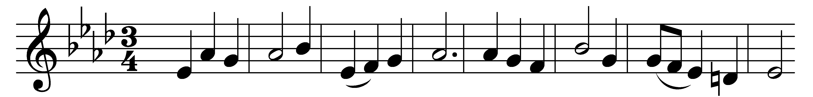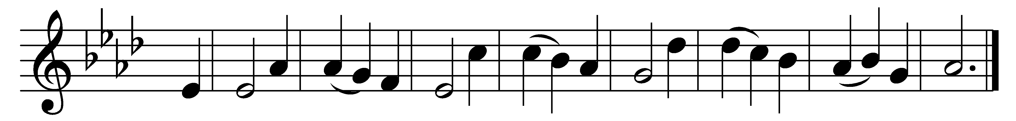

Where cross the crowded ways of life,
where sound the cries of race and clan,
above the noise of selfish strife,
we hear thy voice, O Son of Man.

In haunts of wretchedness and need,
on shadowed thresholds dark with fears,
from paths where hide the lures of greed,
we catch the vision of thy tears.

The cup of water given for thee
still holds the freshness of thy grace;
yet long these multitudes to see
the true compassion of thy face.

O Master, from the mountain side,
make haste to heal these hearts of pain;
among these restless throngs abide,
O tread the city’s streets again;

till all the world shall learn thy love,
and follow where thy feet have trod;
till glorious from thy heaven above,
shall come the city of our God.

Words: Frank Mason North (1850-1935)
Music: From Sacred Melodies, 1815, arranged by William Gardiner (1770-1853)

